Solution Provider Profile

LatitudeLearning
February 2024


Company At-a-Glance
Briefing Report
Name of Product/Offered | LatitudeLearning
Headquarters | Saline, MI
Year Founded | 2003
Geographic Coverage | Global
Website | www.latitudelearning.com
LatitudeLearning Overview and Value Proposition
The LatitudeLearning Learning Management System (LMS) enables you and your partner organizations to manage high-impact training programs that strengthen your business and ensure that your people develop the skills necessary to positively impact your business. LatitudeLearning gives you the ability to align your training programs with critical business drivers and KPIs.
LatitudeLearning LMS is built specifically to manage extended enterprise training programs — the way you want. Easily deliver quality training across the multiple channel networks selling and servicing your product brands — field employees, resellers, service providers, partners, dealers and customers.
The system is based on four principles that are foundational to a high-impact training program:
- Managing Knowledge — The ability to deliver courses using seven different course modalities to each unique training group or job function in your partner network. Simplifying onboarding of staff and team members, personalizing training based on job function(s), managing career development and growth for individuals and delivering training at the point of need.
- Managing Skills — To be an effective team member goes beyond the completion of classes. In extended enterprise and partner networks, there are clearly defined paths for partners to grow from apprentice to master. Those rules are always evolving and ever-changing the LatitudeLearning LMS helps manage that complexity. This includes the ability to manage complex skill paths based on job requirements — the ability to certify individuals — the ability to define staffing and skill mix requirements by organization types — and the ability to certify locations and managers as they maintain their training and skill levels across their teams.
- Delivering Business Impact — All partner networks have established performance metrics that usually stand independently from the training programs that are driving them. We believe it is important that training programs bring those measurements into the training objectives and measurements for their participants. This includes individual performance metrics like Customer Satisfaction, Fixed Right First Time, Units Sold, Parts Sold, Repair Orders Completed and more. It also includes individual and organizational level metrics that are used to ensure partners are performing at the desired level and to differentiate between high-performing and low-performing entities as needed and address the issues as they arise.
- Managing Training at Scale — Partner training programs are complex by nature, and the partners and organizations want some autonomy in meeting those requirements. The LMS is designed to allow for the central definition of what it means to be trained and certified in the network, but it can also be configured to allow partners to manage their own training within the context of the central objectives.
LatitudeLearning understands the frustrations that come with complex skills-based training programs. Our team is your team, tailoring your high-impact training programs to be elegantly managed. Why struggle with LMS software that can’t accommodate your unique training objectives? Deliver a skills-based training program with less effort and achieve your individual, team and organization-level target outcomes.

Screenshots
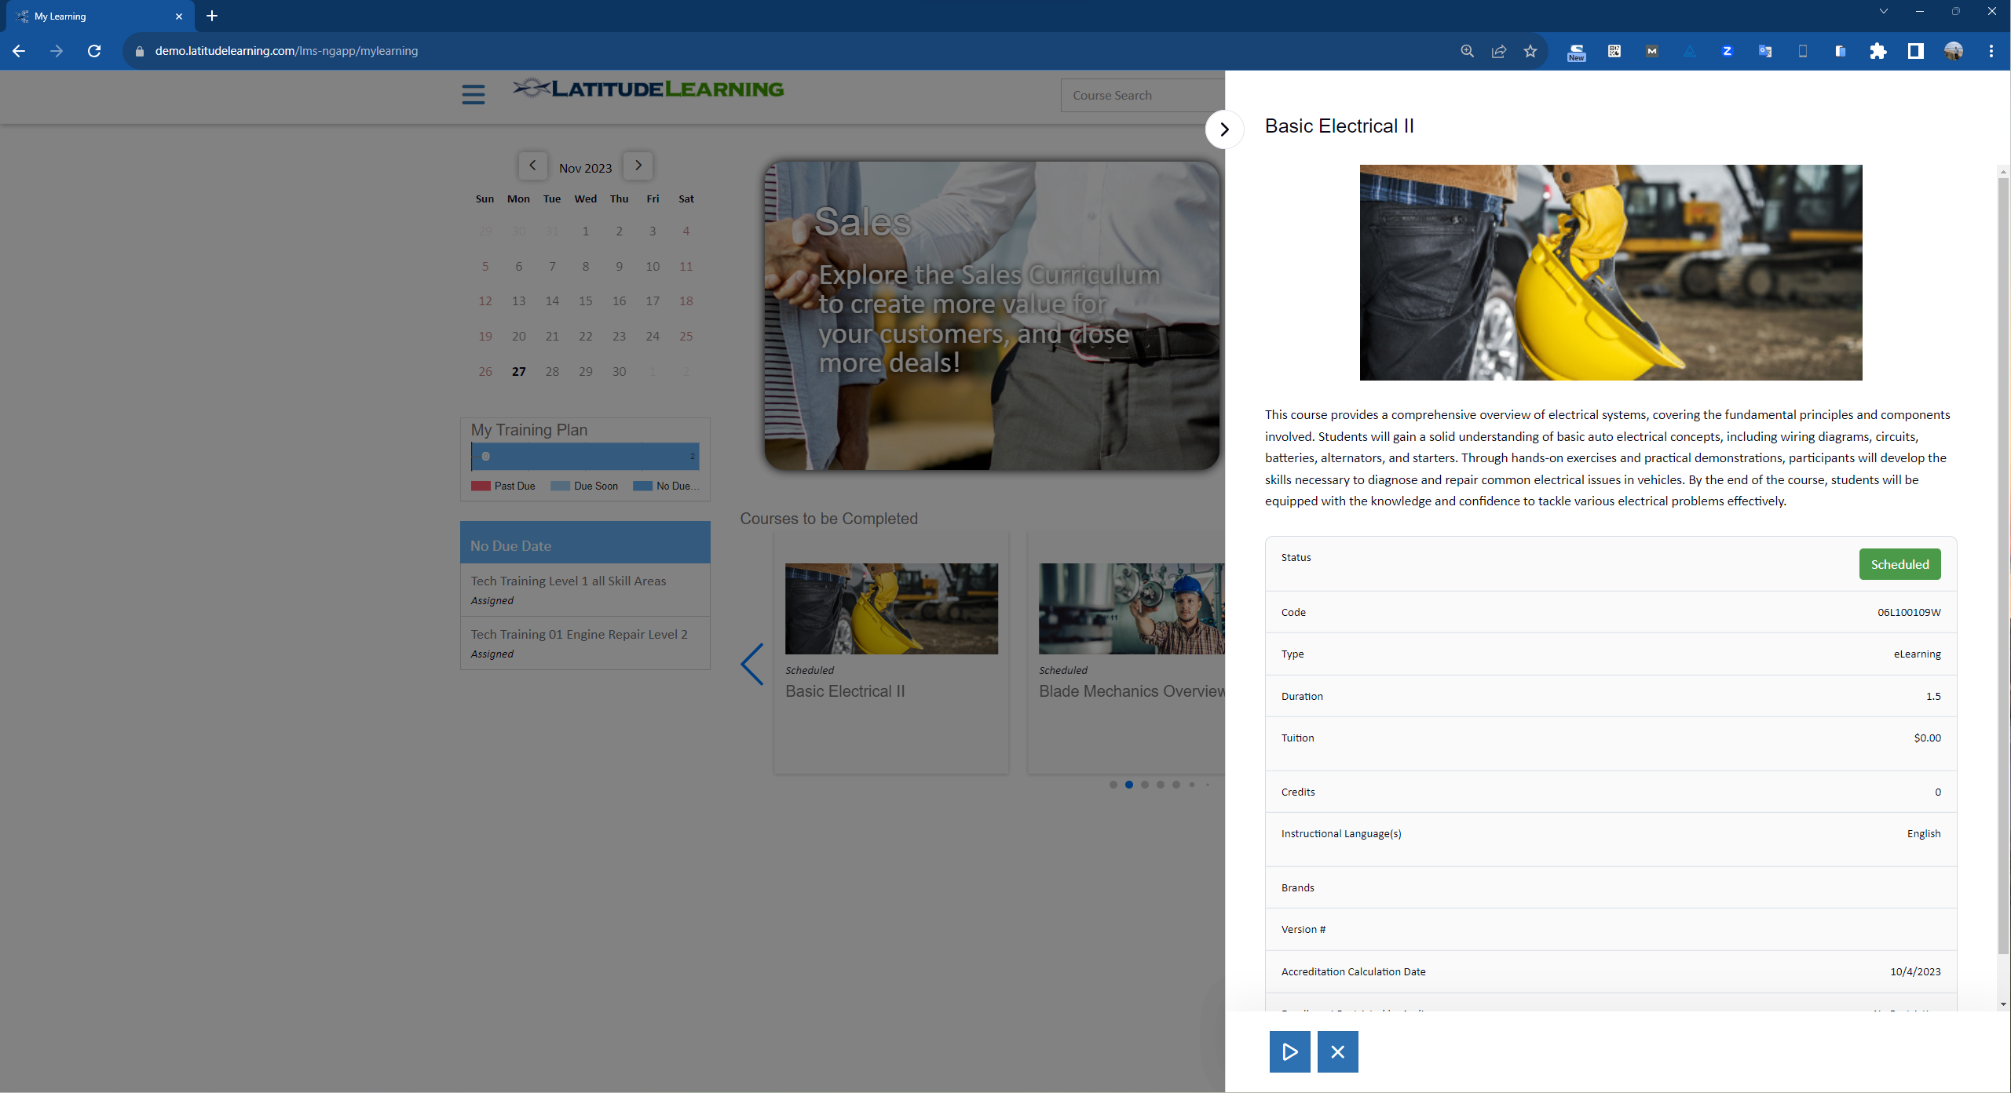

Series 1: LatitudeLearning Home Page Offering Easy Access to Training

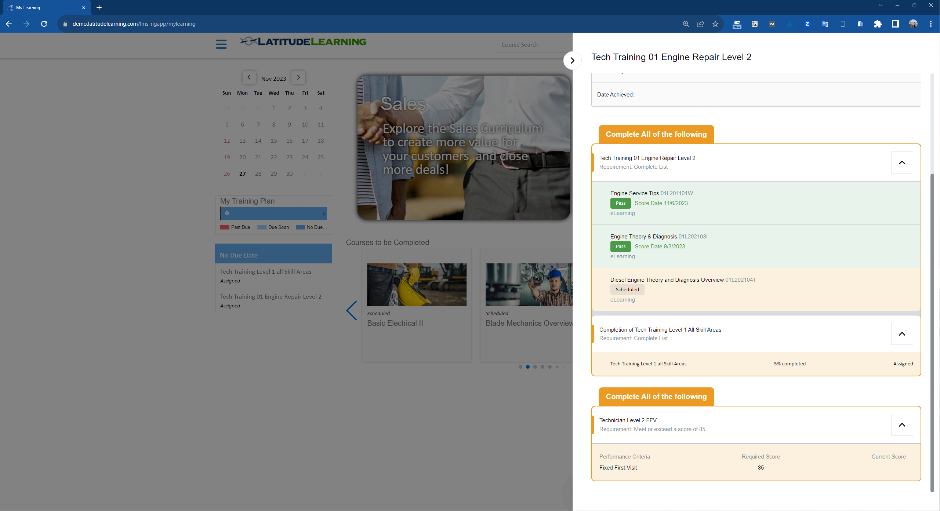
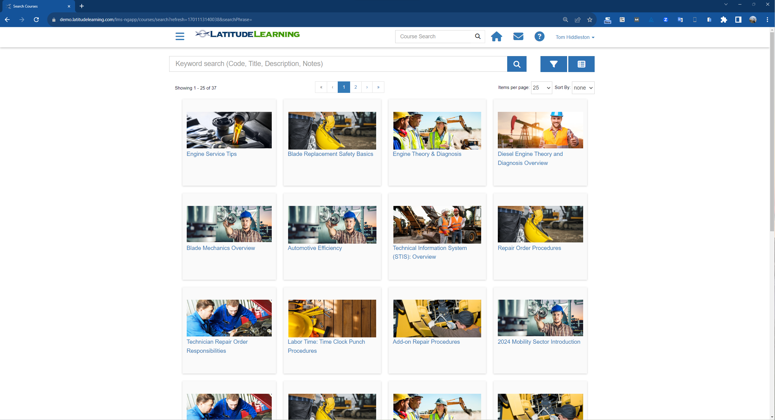
Series 2: Learning Catalog for Easy Access to All Training Materials

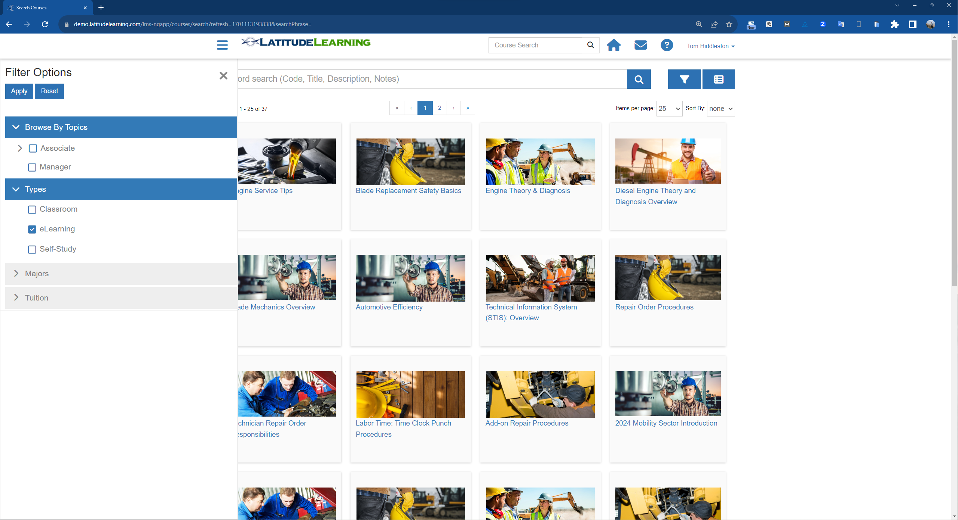
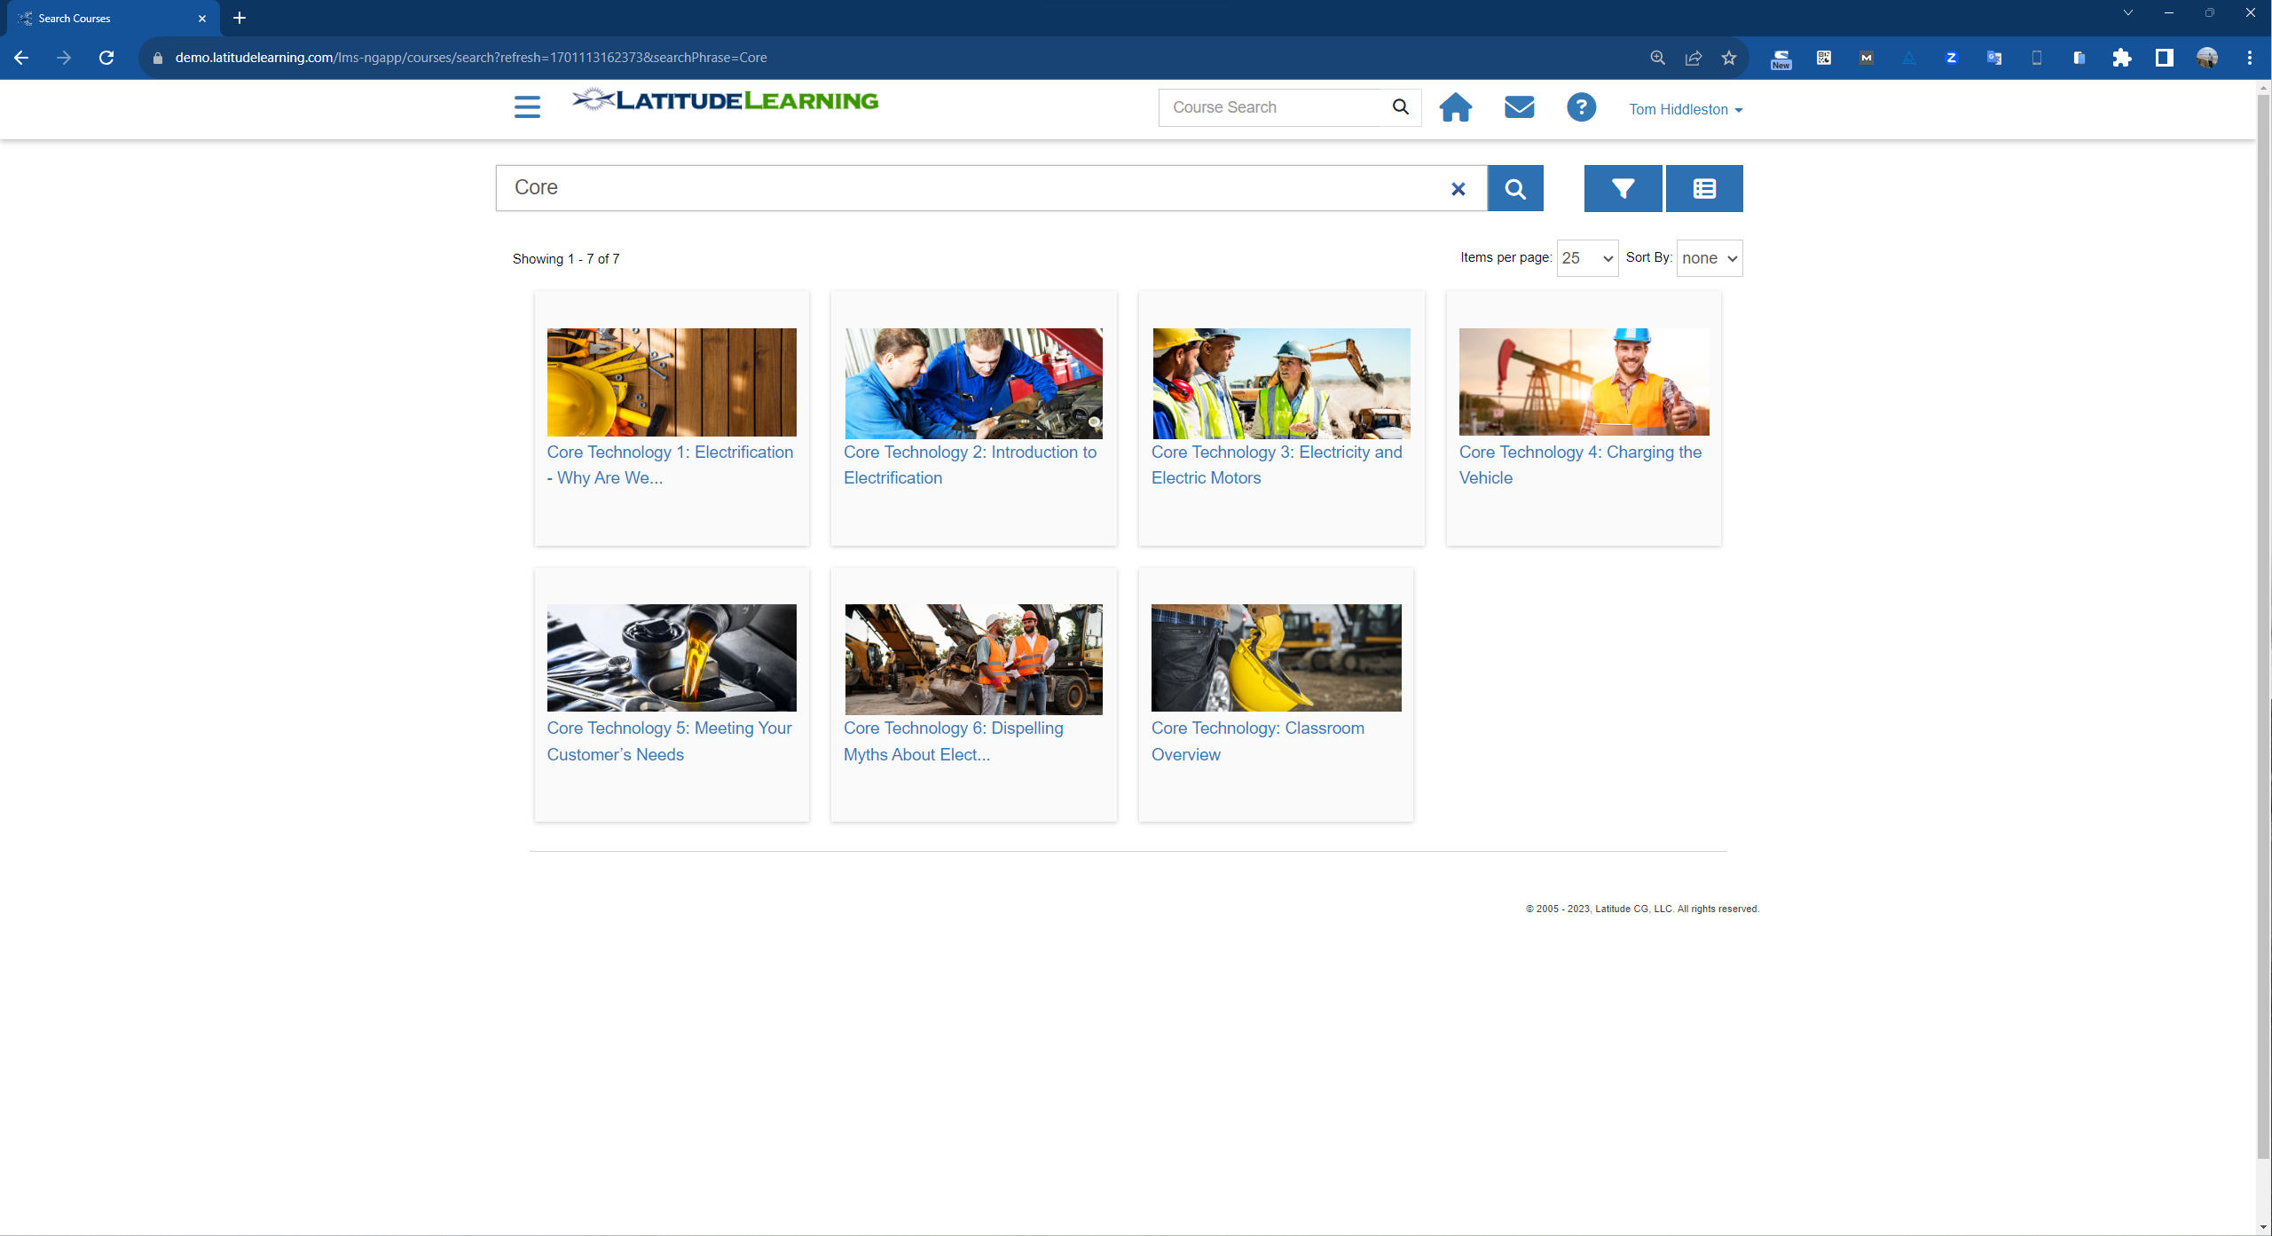

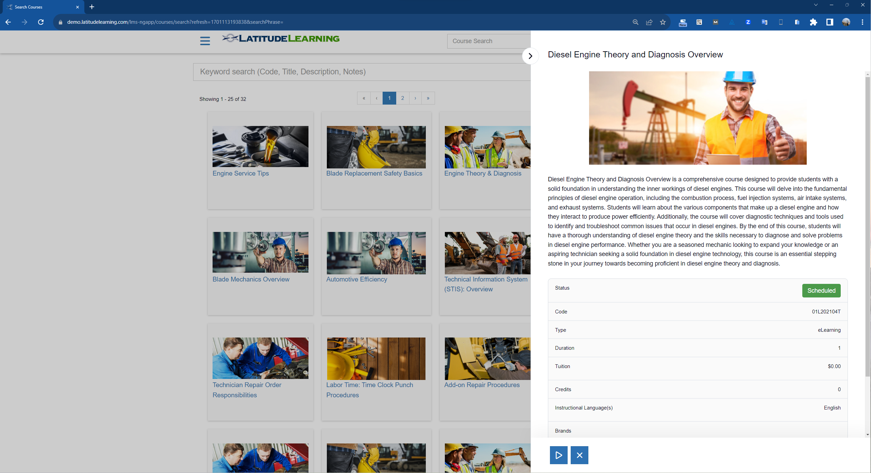
Series 3: Comprehensive Skills-Based Views for Individuals to Know
Where They Are Going and Where They Stand for All Jobs in Your Network
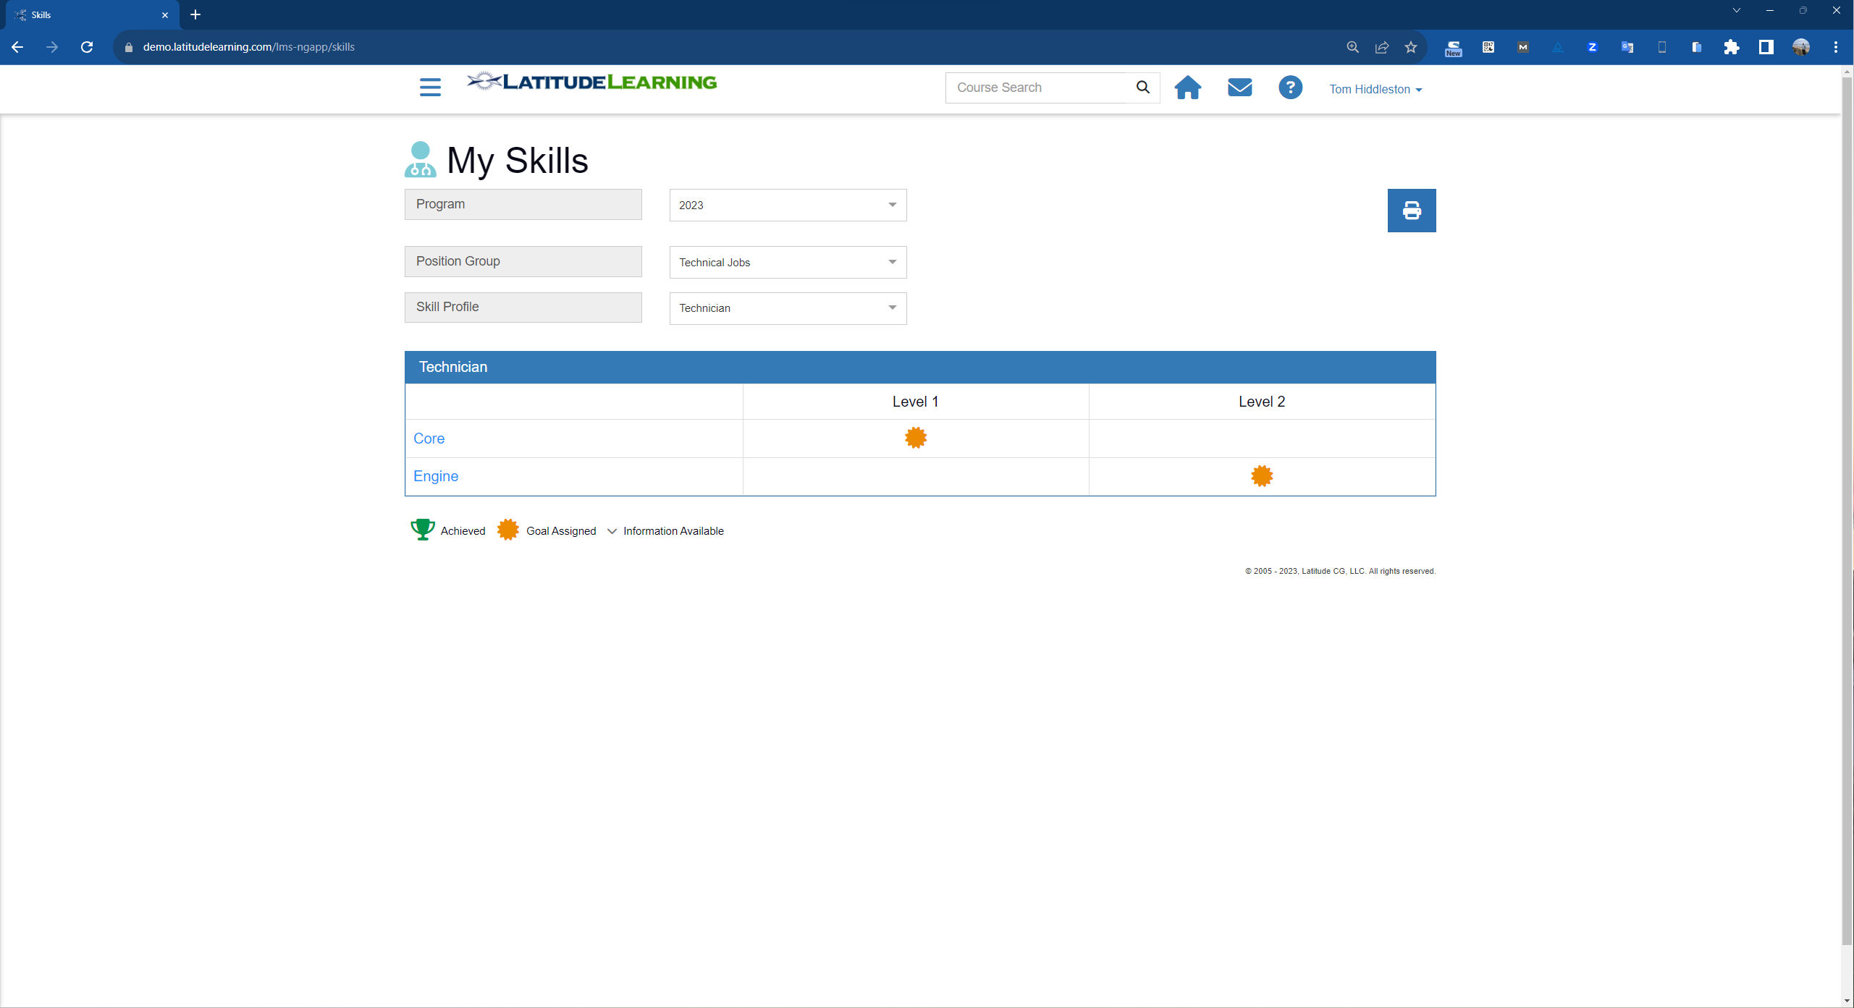
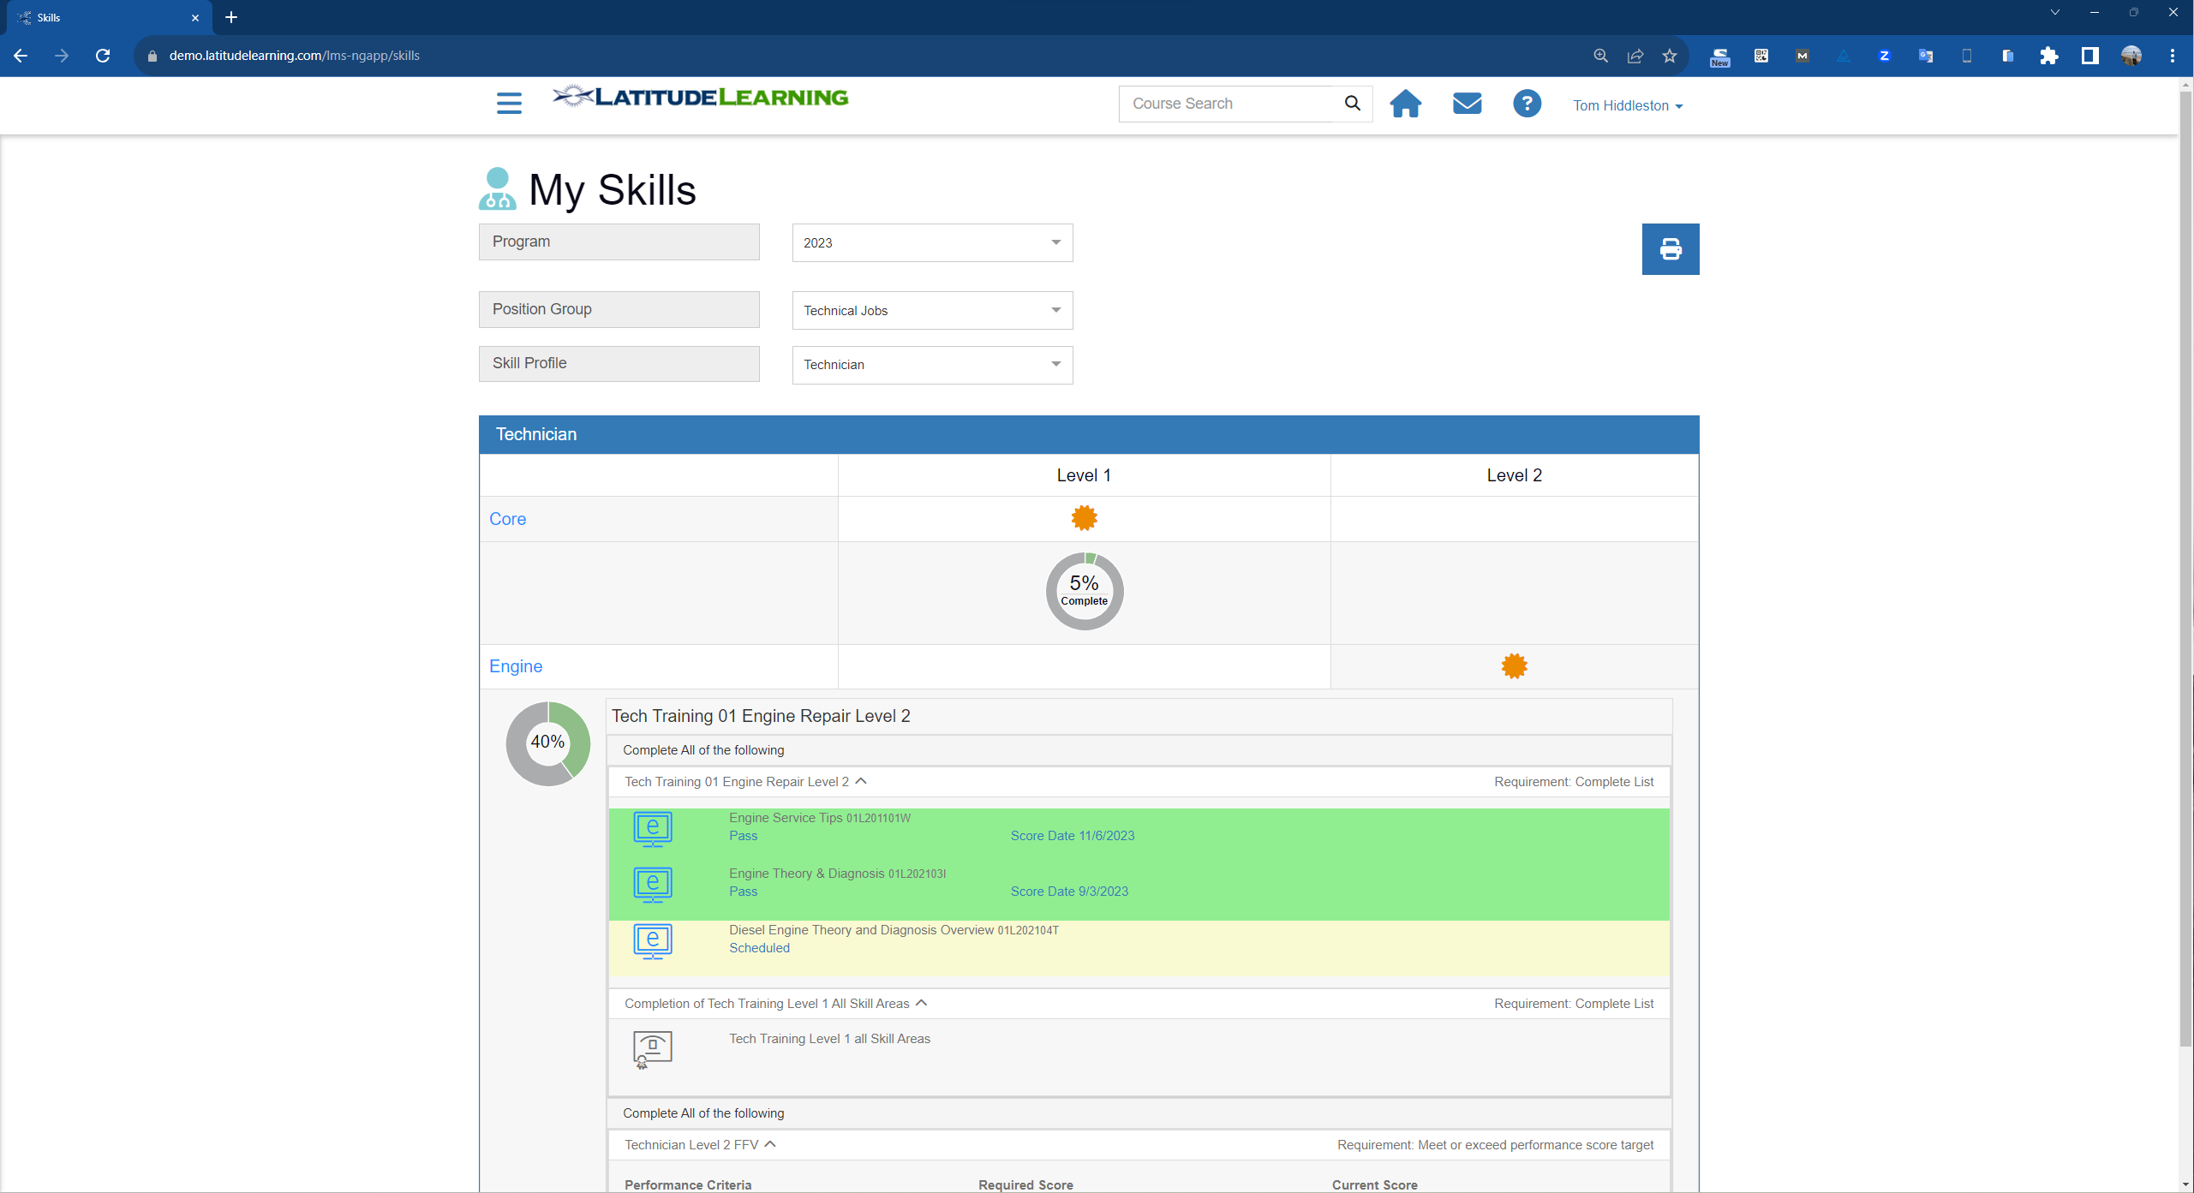
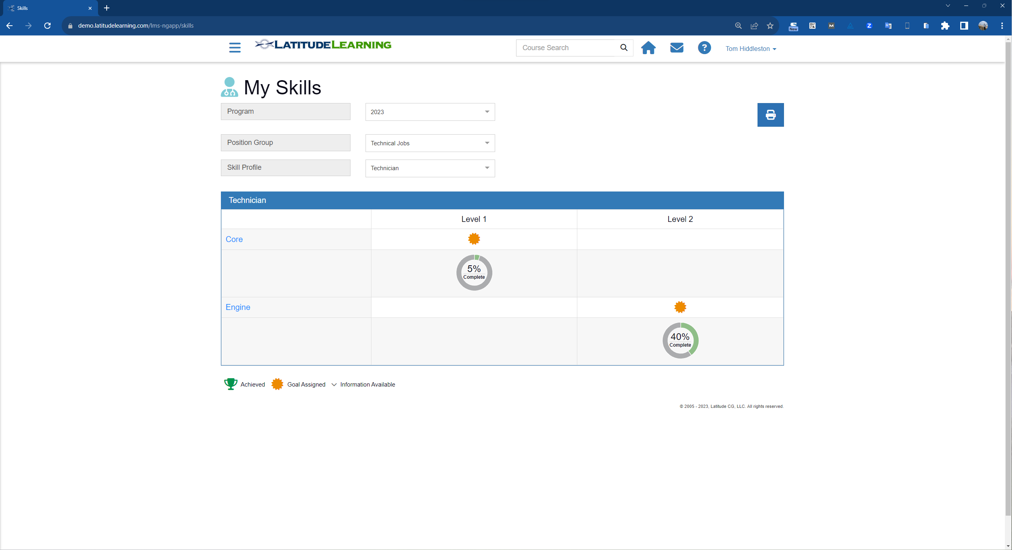

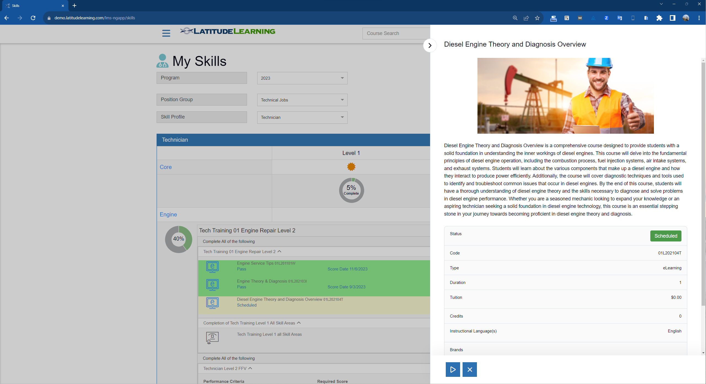
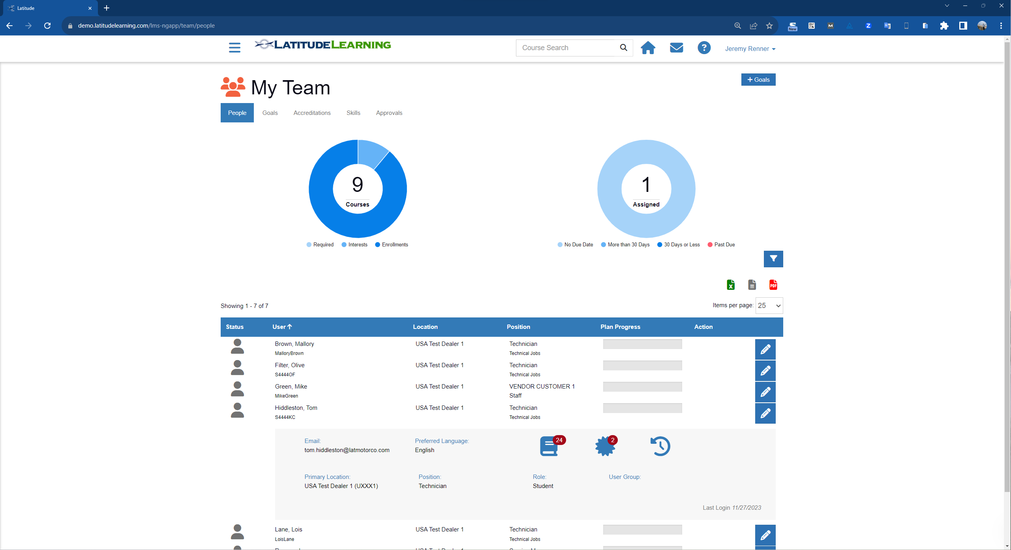
Series 4: Team Management and Individual Training Details

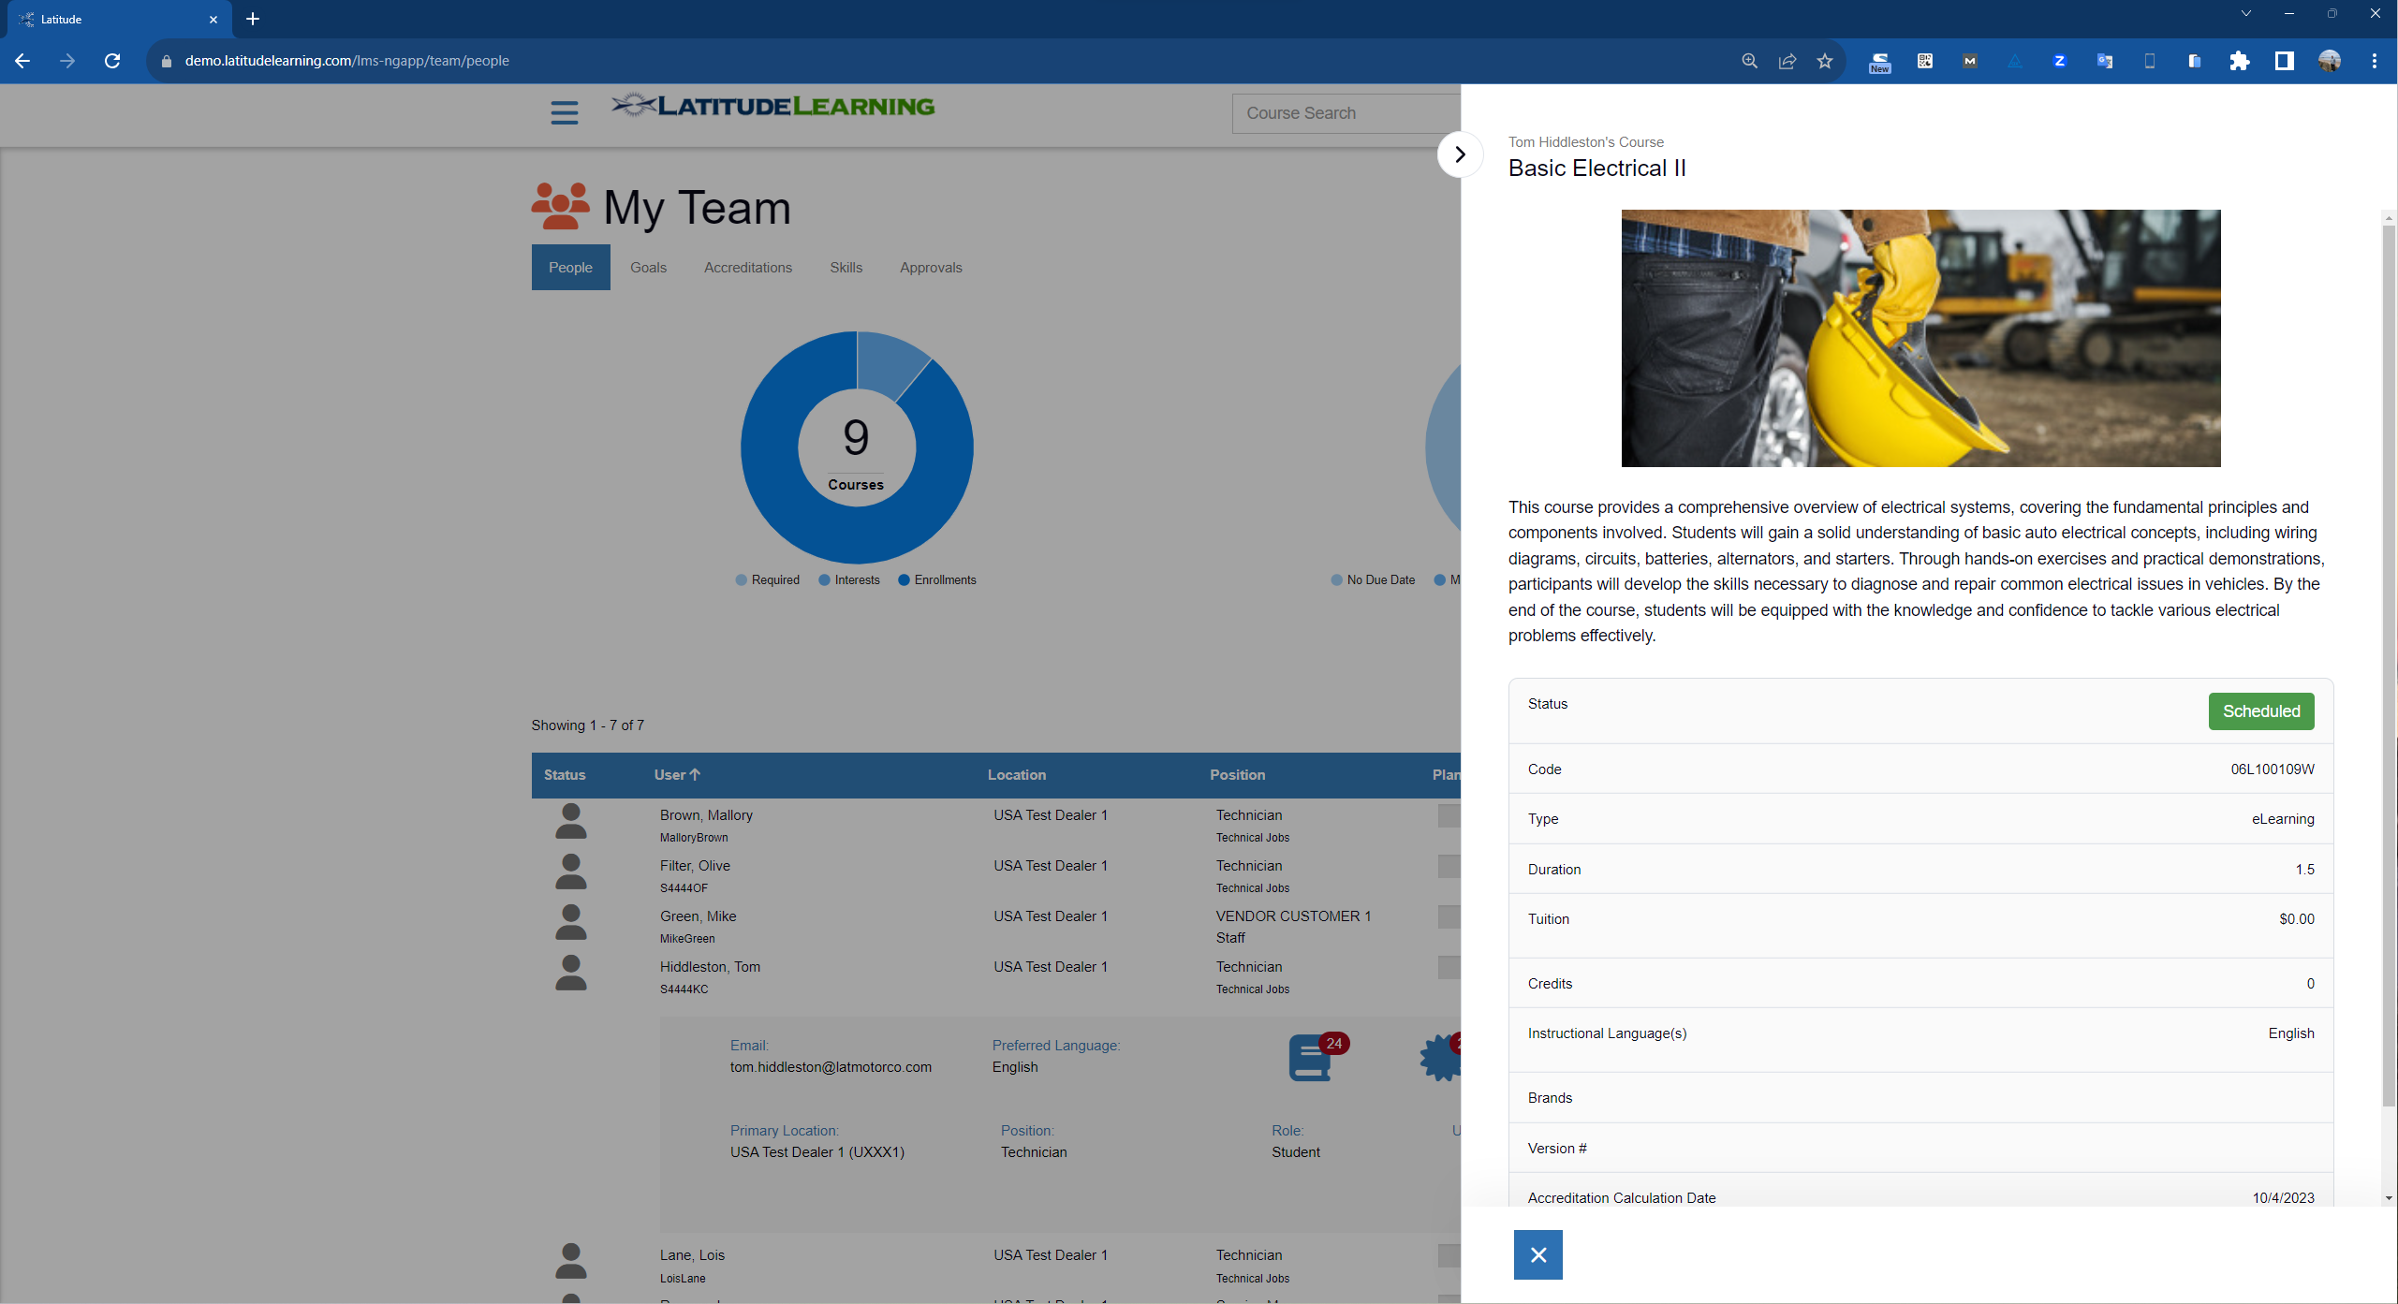
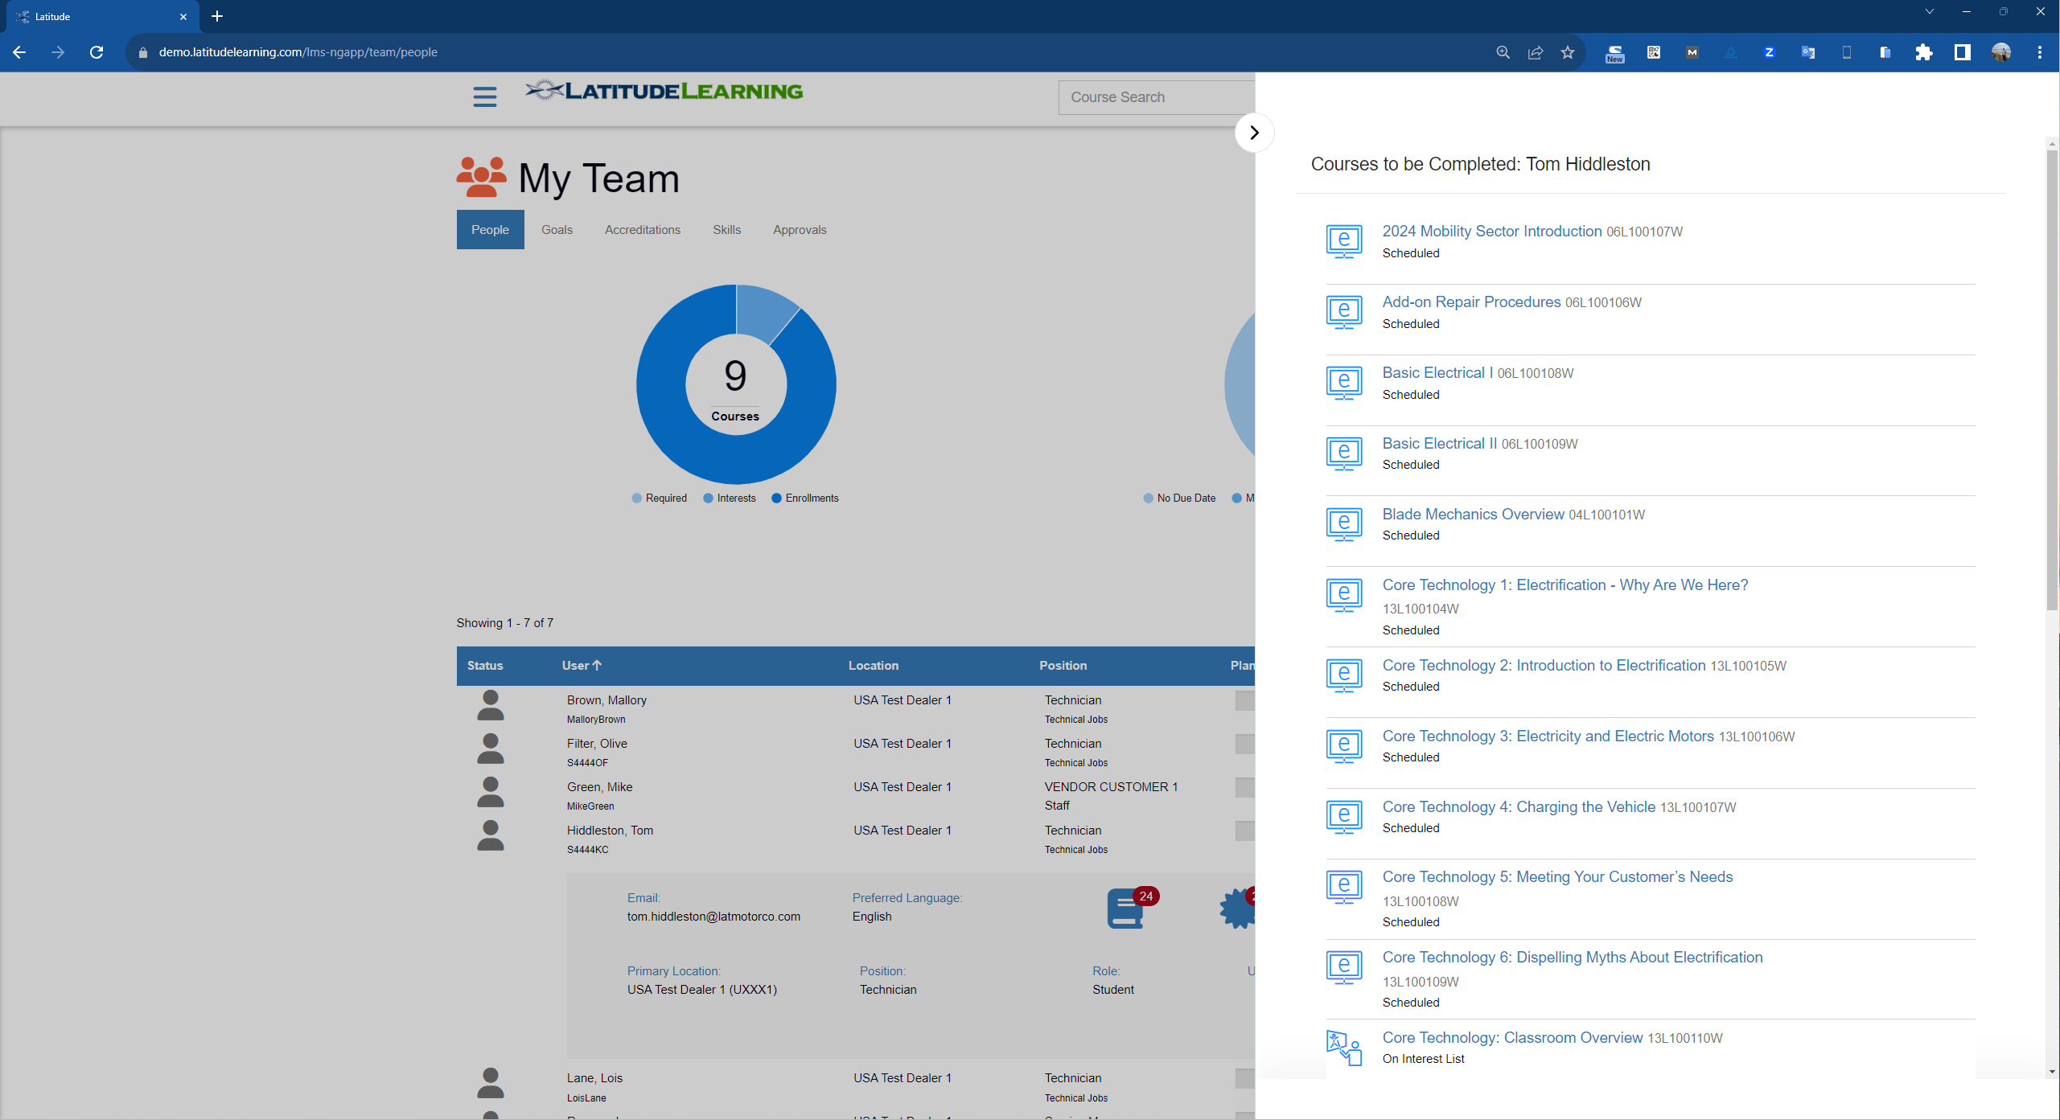

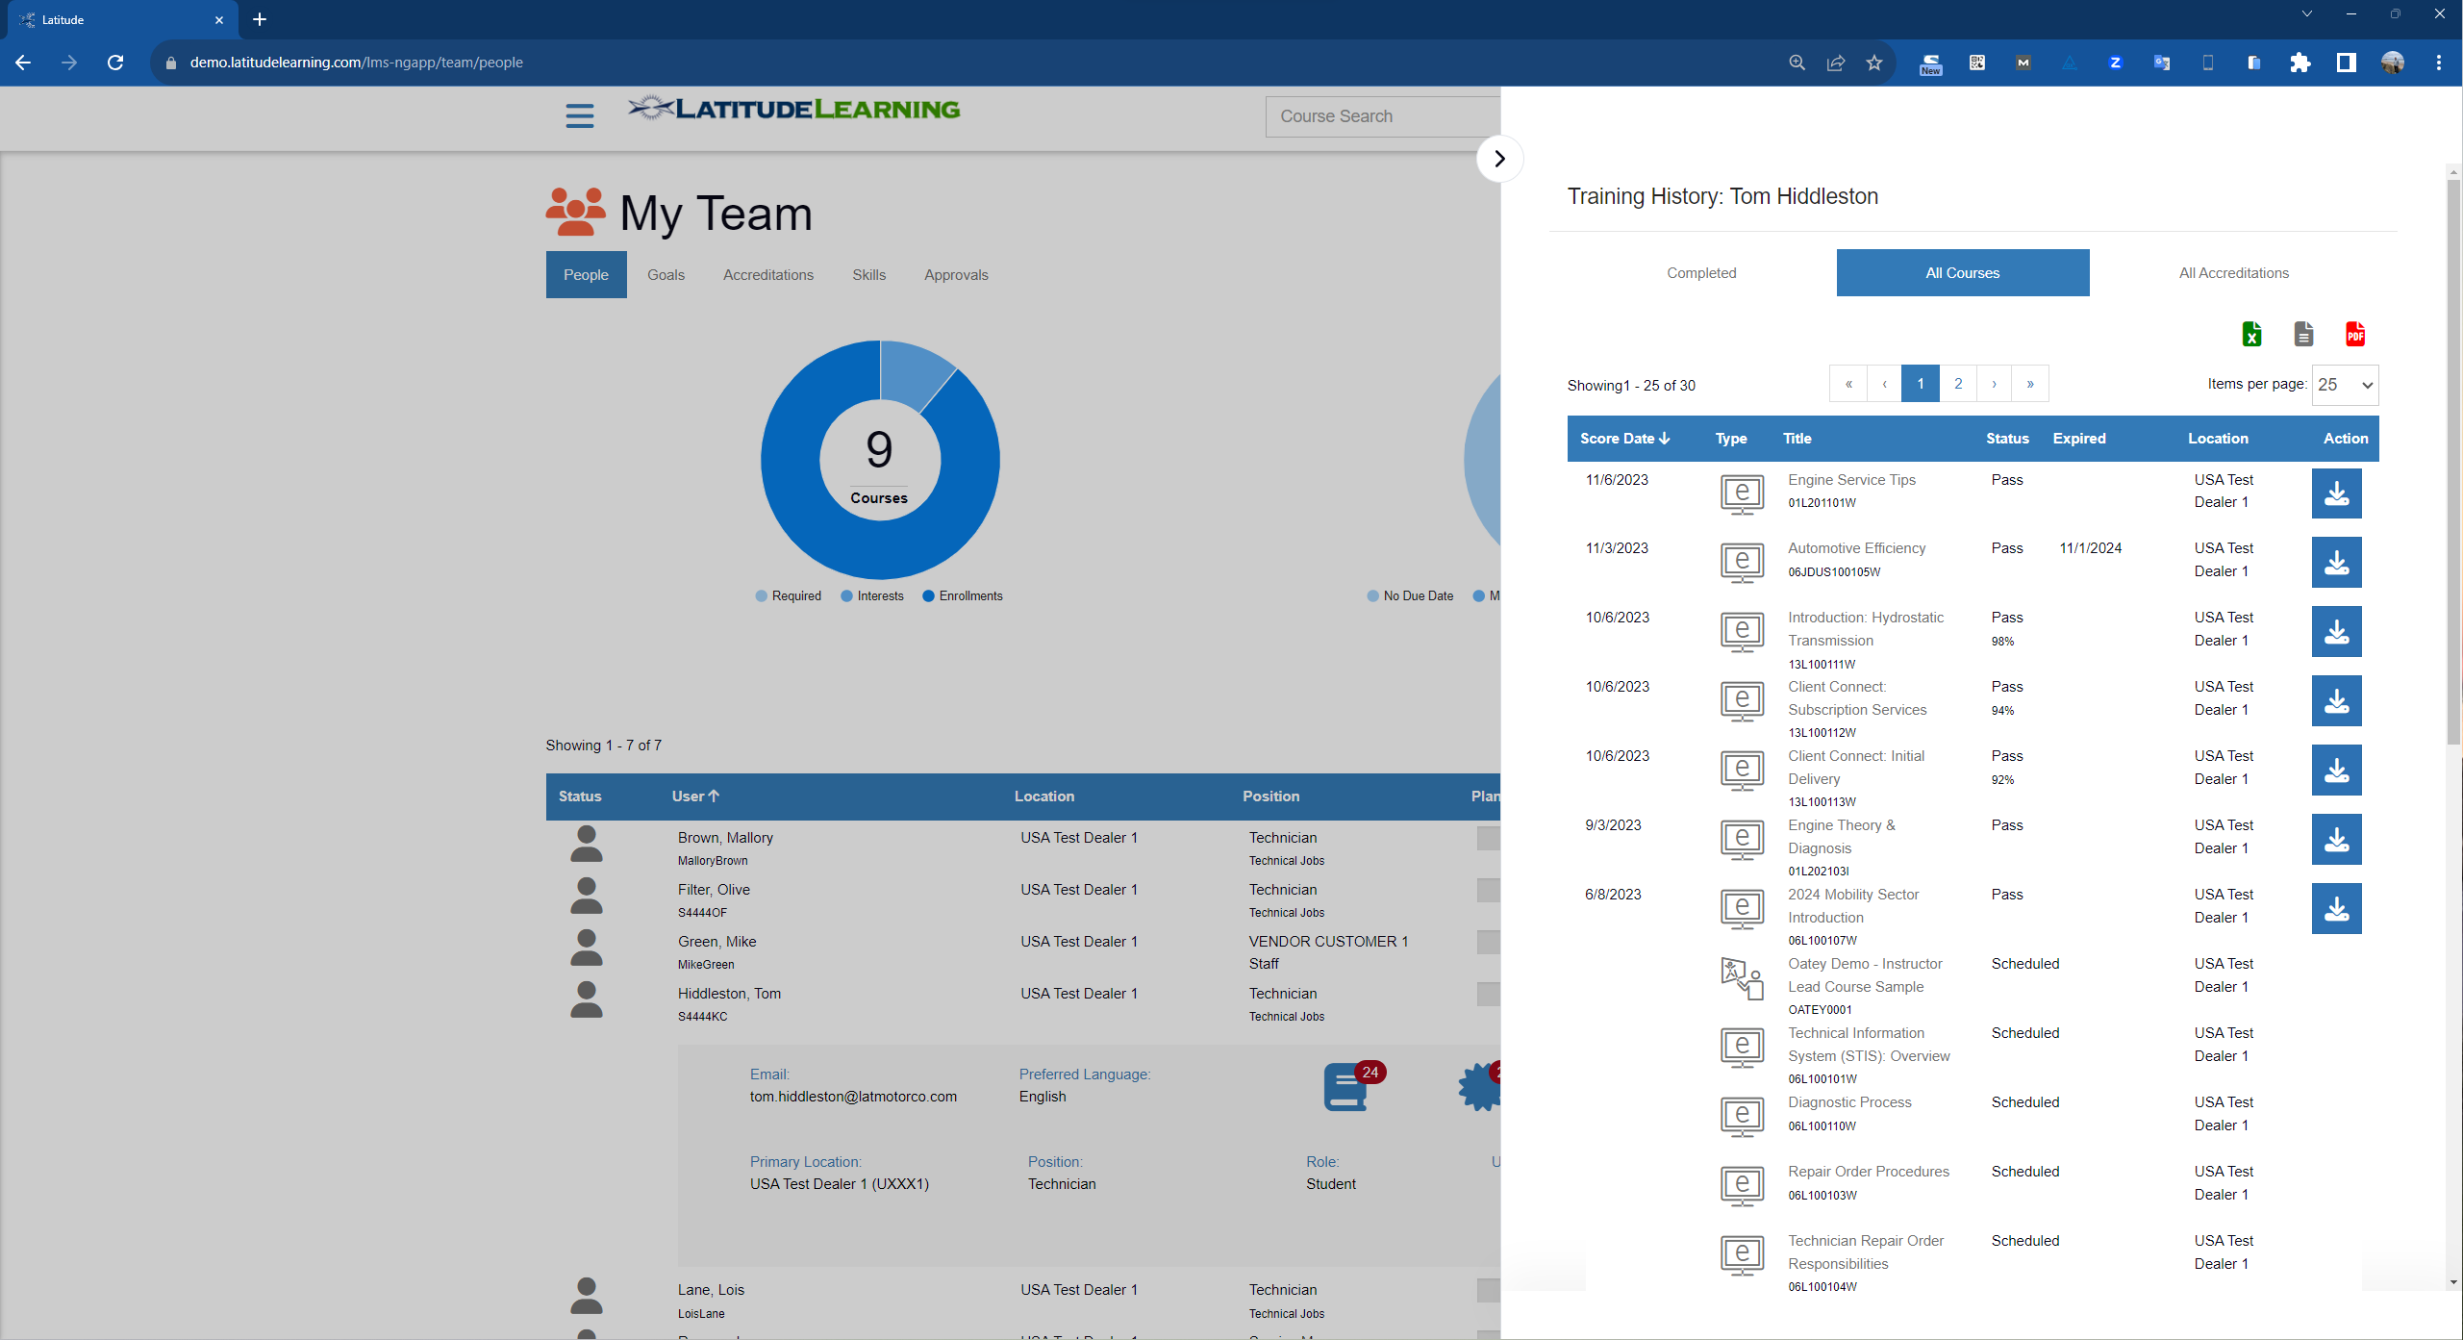
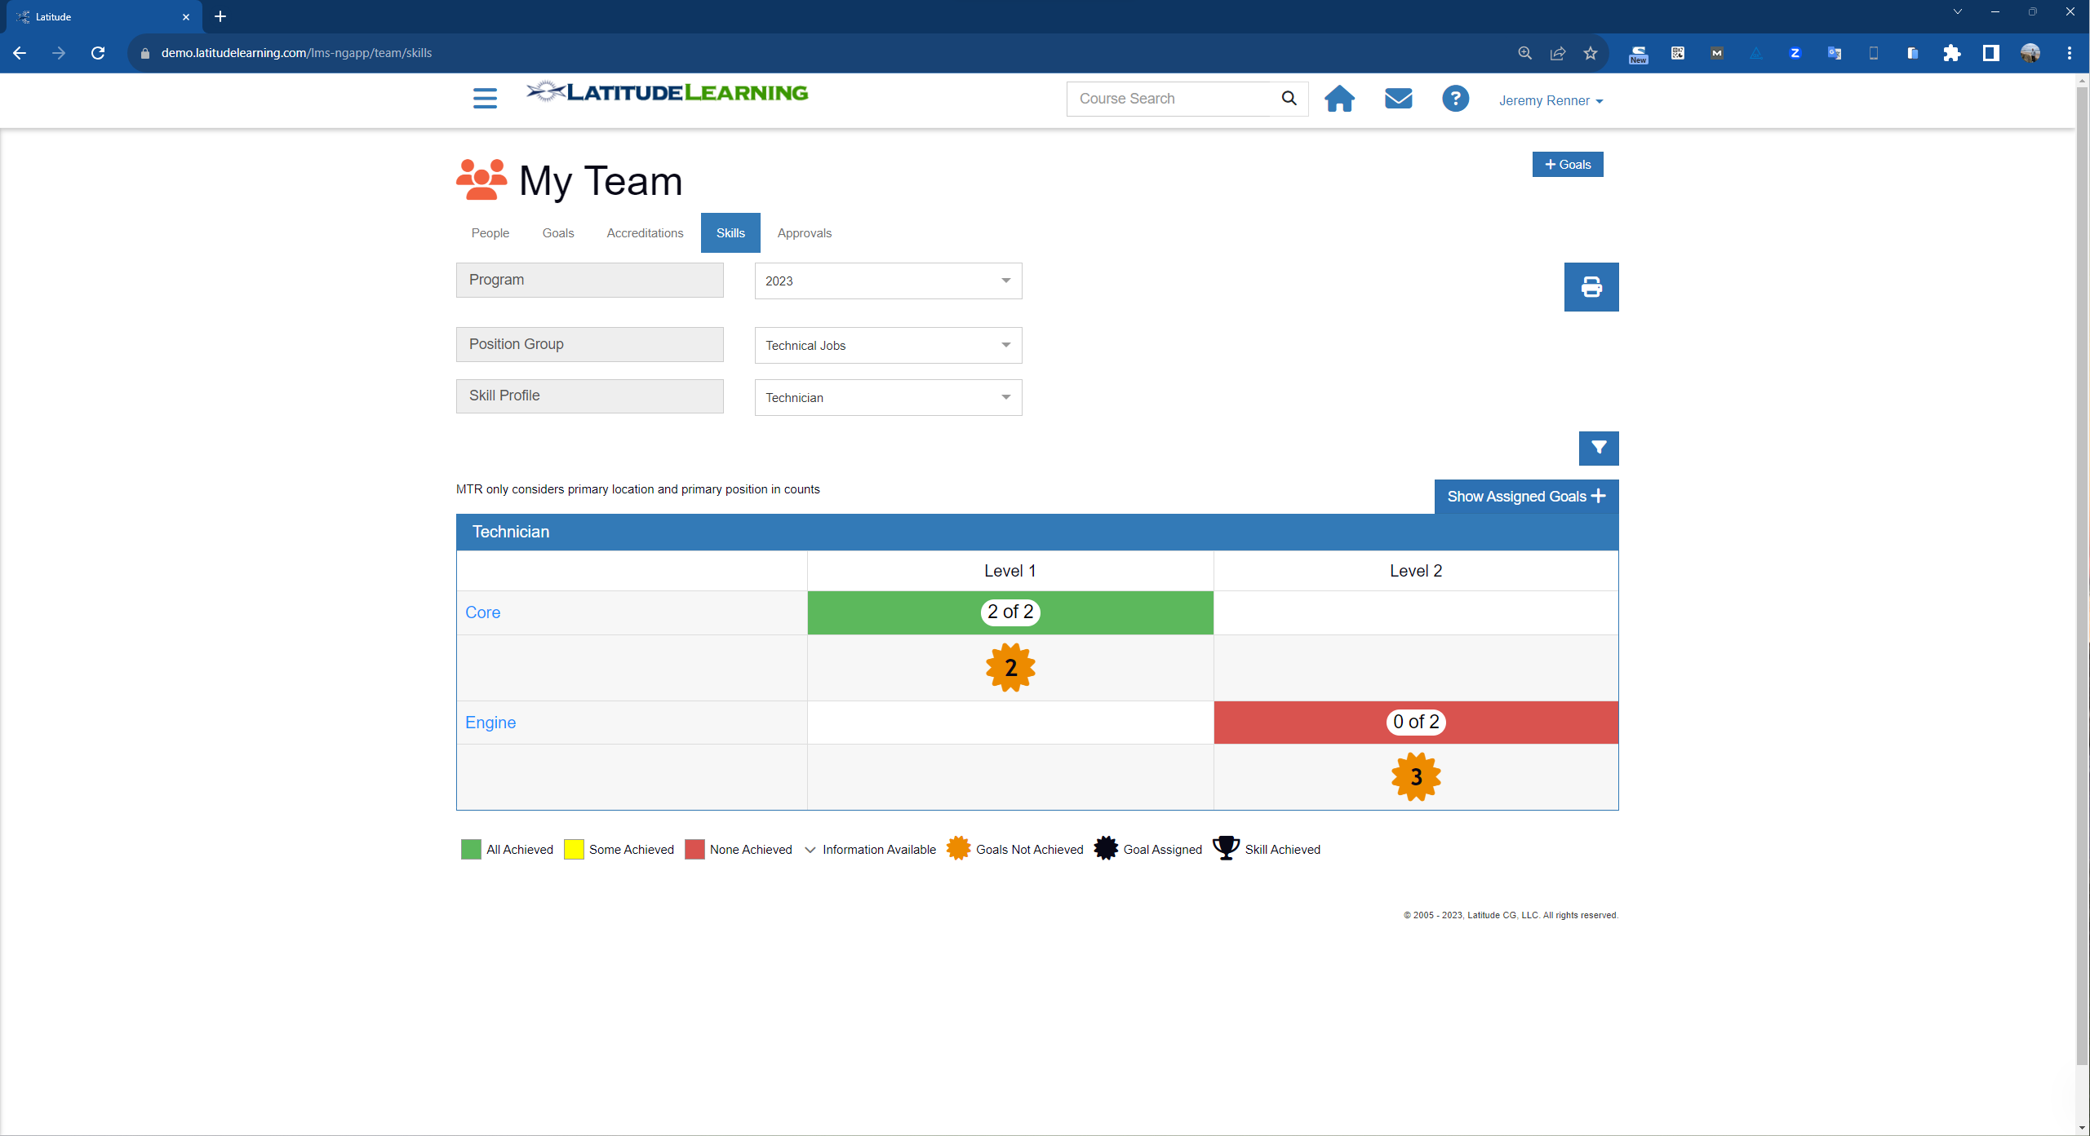
Series 5: Team Management and Overall Training Performance and Skill Visibility

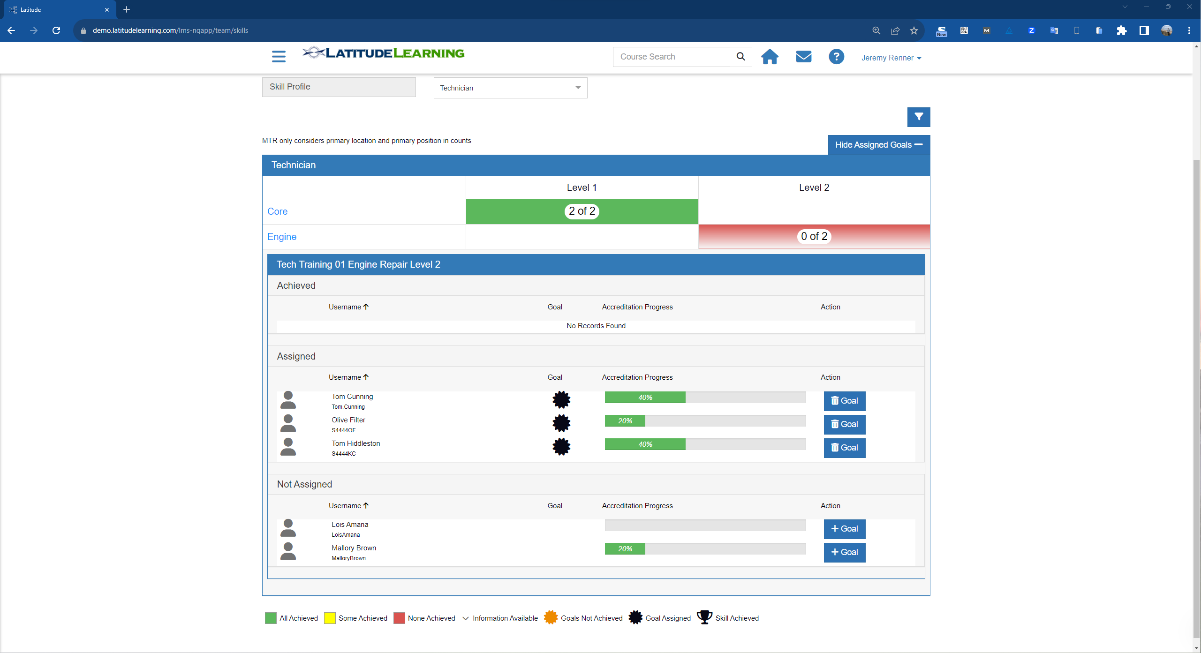
All screenshots provided by LatitudeLearning

Analysis by Brandon Hall Group™
Situational Analysis
The global LMS market is experiencing rapid growth driven by the increasing adoption of eLearning in corporations, academic institutions and government organizations, and is expected to grow to $50.8 billion by 2028. While corporate LMS adoption has boomed, extended enterprise training for partners, resellers, franchises and customers remains an emerging opportunity. The market is somewhat fragmented, with many providers focused primarily on internal employee training.
Challenges to the Business
LMS providers are facing several challenges that include keeping up with evolving learner preferences, the increased need for personalization and customization; handling large volumes of data safely, managing more and more learning content; and high costs for development and operations. Gone are the days when learning organizations focus their technology budgets almost exclusively on the LMS. These days, learning organizations are looking to build a true learning ecosystem. Many providers are responding by seeking to be a “one-stop” solution. There’s also increasing pressure for vendors to offer AI-driven solutions, which many are doing before they are truly market-ready.
Delivering training across distributed partner networks in the extended enterprise comes with unique challenges like managing external organizations, integrating with existing channel management systems and scaling to support thousands of partners. Data security and IP protection are also paramount. For companies reliant on extended enterprise learners for business success, those needs must be accounted for.
Implications for the Business
The shift to mostly remote and blended learning during the COVID-19 pandemic accelerated LMS adoption and created opportunities for providers to address new use cases. Companies that provide user-friendly, scalable and AI-powered solutions are in the best position to capitalize on the growing market. Vendors who recognize that extended enterprise training requires specialized functionality like partner portals, content localization tools and xAPI support for collecting data across systems open up even more opportunities.

Questions to be Answered by the Business
When considering the purchase of a Learning Management System (LMS), companies should ask themselves the following five questions:
- What are our specific learning objectives and requirements? Clearly defining the organization’s learning goals, target audience and desired outcomes is essential to selecting an LMS that aligns with these objectives.
- How scalable and flexible does the LMS need to be? Assessing the scalability of the LMS is crucial to ensure it can accommodate the organization’s current and future needs. Consider factors such as the number of users, courses and content that the LMS should support.
- What integration capabilities do we require? Determine whether the LMS needs to integrate with existing systems such as HR software, content management systems or video conferencing tools. This will help streamline workflows and data exchange.
- What’s our budget and total cost of ownership? Consider the financial aspects of the LMS, including licensing fees, implementation costs, ongoing maintenance and support. Assess the potential return on investment and the value the LMS brings to the organization.
- How important is the user experience and interface? Evaluate the usability and user experience of the LMS. Consider the needs and technical proficiency of the learners to ensure the LMS is user-friendly and intuitive. A positive user experience can enhance engagement and learning outcomes.
- How well can this provider support our extended enterprise needs? Managing training for the extended enterprise brings a unique set of challenges. The ability to manage the business components of extended enterprise training including revenue, payments, taxation, etc., is key if extended enterprise is part of your scope.
By asking these questions, companies can gain clarity on their specific needs, evaluate the suitability of different LMS options and make an informed decision that best meets their requirements.

LatitudeLearning as the Answer
When it comes to supporting the learning needs of the extended enterprise (those audiences beyond direct employees), Latitude has gone all in on the capabilities and functionality that organizations require.
Their stated goal to be the premier solution for the extended enterprise is well in hand. In fact, beyond the minimum core functionality that you should expect to find in any LMS solution, Latitude has honed its approach to skills to allow for critical workforce and talent management intelligence in a way that’s clearly superior to many other systems.
The foundation of their customer base in the automotive industry has led to the building of a platform that’s able to deliver high-impact extended enterprise learning focusing on knowledge acquisition, skill development, alignment with metrics, management at scale and incentives. Having found particular success in a sales representative use case and in the parts and repair use case, Latitude has shown a consistent ability to drive learner engagement and business results by ensuring a well-trained workforce. This experience is easy to repeat and scale regardless of the specific industry.
Latitude proves that they are driven by ensuring that learners know what they need to know to do their job. They also support managers in having a clear line of sight into where their workforce stands regarding required or expected skills.
By enabling detailed skills profiles driven by role and job title, the system lays out a clear path forward. Allowing for the designation of levels of mastery and linking those levels to engagement/completion of specific learning content places the individual in very firm control of their own learning agenda.
Latitude’s platform also accommodates specific goals and goal rules for learning content that can be managed at the enterprise and team level. This matters because Brandon Hall Group™ research continues to show that personalization and autonomy when it comes to choosing how, when and what to learn at work makes for higher learner engagement and better overall outcomes.
Other aspects of Latitude’s platform to take note of include the ability to seamlessly manage live instructor-led training and eLearning from the same platform; and their connections window that allows companies to leverage their learning hub as the access point to anything workers need to complete their work, including intranet sites, helps sites, other learning platforms, ERP platforms and the like. While these do not represent true integrations, driving traffic to the learning hub by making it the technology hub serves learning well.
You’ll notice that the look and feel of the Latitude environment seems somewhat dated compared to other systems. However, the powerful capabilities and ease of navigation quickly overshadow that concern. For organizations needing to secure an effective platform to serve the needs of extended enterprise learning audiences, Latitude deserves a place on your shortlist.
- Matt Pittman, Principal Analyst, Brandon Hall Group™
Contribution Team:
Michael Rochelle, Mike Cooke, Rachel Cooke, Claude Werder, Pat Fitzgerald
