Solution Provider Profile
Title
September 2023



Company At-a-Glance
Briefing Report
Name of Product/Offered | LearnUpon
Headquarters | Dublin, Ireland
Year Founded | 2012
Geographic Coverage | LearnUpon is a global company with an HQ in Dublin (IE), and offices in Philadelphia (USA), Salt Lake City (USA), Sydney (AUS), and Belgrade (SRB).
Industries | Construction & Manufacturing, Financial Services, Healthcare, Nonprofit, Retail, Services, Software & Technology, Training companies, Associations.
Website | www.learnupon.com

LEARNUPON OVERVIEW AND VALUE PROPOSITION
LearnUpon was founded with a belief: learning should be simple, and its impact should be big. And today, LearnUpon is helping businesses around the world do just that.
By championing learner-centric experiences and results-focused support, LearnUpon's LMS makes it easy for global organizations to centralize and build learning strategies that impact what matters: performance, retention, and growth.
A centralized solution to manage, deliver, and track training
With LearnUpon, businesses can build strategic learning initiatives all through a single solution, enabling them to:
- Streamline training administration to reduce costs and increase operational efficiencies. For example, HR teams delivering training to employees can build a course in LearnUpon, and automate tasks like user enrollment so that training is rolled out quickly and easily.
- Create an engaging learning hub where learners can effortlessly access and take training via a direct login or single sign-on, so there are zero barriers to training.
- Deliver a dynamic blended learning experience where learners can access on-demand or required courses on mobile or desktop, participate in webinars and instructor-led training, and be assessed via exams and surveys.
- Scale up training delivery and eliminate the need for multiple learning solutions by enabling businesses to create multiple, distinct learning environments for each unique audience, within one solution.
- Track the impact and return on investment of training with out-of-the-box reports and integrations.
Drive employee productivity, efficiency, and retention
With LearnUpon, organizations can build, shape, and deliver large-scale employee training programs that drive strategic goals and business transformation, including:
- Delivering easily accessible onboarding training from day one that enables new hires to acquire the knowledge needed to be productive in their roles - fast.
- Increasing retention by delivering training that allows employees to learn and grow in their careers, thus reducing costly turnover and the loss of key knowledge and experience.
- Driving productivity by offering employees role-based, skills, and product training that aids them in performing at their best.
- Safeguarding the business against compliance violations by providing employees with mandatory training and ensuring compliance is recorded so organizations are always audit-ready.
Drive customer and partner success with training
LearnUpon enables organizations to create environments via Learning Portals to train customers and partners at scale so they can achieve their business goals, including:
- Delivering easy-to-access onboarding training to new customers and partners from the get-go, reducing ramp-up time and time to value.
- Increasing retention and year-on-year growth by rolling out product training and continuous learning that helps to maximize the value these audiences are getting from the business.
- Enhancing product adoption and stickiness by providing training that enables customers to fully understand how to utilize and succeed using the product.
- Reducing support queries by providing training for commonly asked queries, thus freeing up an organization’s support teams to focus on having more strategic, high-impact conversations with partners and customers.
- Building awareness and protecting the brand by offering authorized customer and partner certification programs. This enables customers to showcase their expertise using the business's product and have it as a badge of honor. For partners, businesses can ensure only those who've completed the training can sell their product and make sure they’re impactful in doing so.
- Generating new revenue streams by selling courses to customers and partners via LearnUpon’s out-of-the-box eCommerce storefront and Shopify integration.
At a time when learning management systems exclusively serviced internal training, LearnUpon was built to support internal and external training in equal measure. Here’s some examples of how LearnUpon is helping 1,400+ customers in over 35 countries achieve their goals:
- “We’ve experienced exponential growth over the last 2 years using LearnUpon, and we’re now training more than 10,000 people a year.” - Scott Edwards, Director of Netskope Academy at Netskope
- “LearnUpon enables us to effectively share ACE education to over 90,000 health and fitness professionals in an easy-to-access and engaging manner. In turn, our professionals apply their learning to positively impact millions of lives across the world. The domino effect is expansive!” - Jacque Crockford, DHSc., Senior Product Manager at the American Council on Exercise
- “We’ve reimagined our implementation process, adding LearnUpon as a seamless and necessary part of each onboarding.” - Moriah Ujano, Member Education Manager at WebPT
- “We’re a lean team and LearnUpon makes our job easier so we can focus on improving our programs, achieving our KPIs, and ultimately making Sonic the best place to work and shop.” - Douglas Bryant, VP of Talent Management, Training, and Recruiting at Sonic Automotive
- “With LearnUpon, our training not only ensures we get consistent results for our clients, but we also see how growing a learning culture positively impacts our employee turnover, performance, and happiness.” - Jennifer Hovestadt, Senior Training Manager at Premium Retail Services
- “If we look at compliance, like GDPR and child safety, if we tried to do training without the LMS, it would have cost us probably £100,000 in just meeting time, people hours, organizing - all the stuff that you have to do. Now that it's all online, we no longer have to spend that time and cost.” - Lisa Slack, Head of Product Development at Hillarys
- “Cost savings were $200,000, actual and projected. Additionally, our support calls went down by 89%. There was a huge, huge difference in calls we would get where installers were having problems.” - Layne Northsea, Technical Training and Documentation Manager, ChargePoint
LearnUpon Platform: Put the learner first
LearnUpon is built to put the learner first, helping customers create an easy, engaging, and enjoyable experience that makes learner goals simpler to achieve.
- Easy to use, easy to navigate experience: An intuitive and easy-to-use experience that enables learners to continuously engage with, and manage, their own learning journey.
- Access anything, any time, on any device: Whenever they want, and wherever they are, learning on the go is easy - with a fully mobile responsive platform, and native mobile apps.
- Experience personalized, interactive learning: Boost interactivity with personalized learning, and features that motivate, remove barriers, and ultimately drive learner engagement.
LearnUpon Platform: Centralize your learning
Centralize learning and streamline how training is created, managed, and delivered, within a single solution.
- The LMS to drive efficiencies: Easy to use and quick to set up so customers can spend less time on training tasks and more on achieving strategic goals.
- One central place for all learning: Create unique environments in seconds to train any audience - employees, customers, partners, members - and integrate with a range of systems via API, SSO, Webhooks or out-of-the-box integrations so customers have one central hub for all your training, no matter the audience.
- Track, measure & amplify impact: Customers can arm their teams with the data they need to track and measure training performance, and tie learning insights back to real business results to prove return on investment.
Features
- Course Creation: Easily create versatile learning programs – extensive and multi-part or small and bitesize – with a range of interactive content options, including webinar and instructor-led training, SCORM and xAPI files, documents, videos, and on-the-job checklists. Separate content into topics called modules, where any number of modules can make up a course. Guide learners, with multiple linked courses wrapped into a learning path. Build a catalog, where learners can browse and enroll on-demand.
- Training Delivery: Make learning programs informal and self-service, or structured and mandated. Simplify the training experience for learners and reinforce essential points with exams, assignments, and knowledge checks using built-in LearnUpon features. Improve programs with learner feedback, using detailed surveys and public Course ratings and reviews.
- User Management: Automate user creation and enrollments, managing large numbers of learners with bulk upload and the API. Seamlessly integrate LearnUpon with a CRM or HRIS so that new users are added to the LMS, as they are added to the other systems. Organize users with specified attributes into different groups. Show only relevant content to each group, providing learners with a tailored experience, while making it easier to pull group-specific reports to monitor progress. And the ability to delegate tasks with a user structure dedicated to the organization’s needs with user types and permissions.
- Learner Engagement: Gamification and leaderboard features encourage teams to hit their goals and place a spotlight on the best performing learners. Automatically provide learners with personalized completion certificates and set automated alerts when it’s time to re-certify. Apply, record, and track internal and external learning credits in one cohesive experience.
- Portals: Portals enable customers to configure training differently for each target audience – like having multiple LMSs controlled in one place. With LearnUpon’s portals functionality, companies can segment training for different audiences, such as customers or partners, and easily scale training from 100s of users to tens of thousands. Customers can deliver different content to distinct audiences with ease and manage content at scale with the ability to copy, edit, and share courses between portals.
- Reporting: LearnUpon’s export-ready Reports can be used to track user progression, exam results, survey responses, training histories, and much more. Filters can be applied to reports, like date ranges, before exporting them – so customers can get the most relevant information. Save time with scheduled reports which can be exported and shared via Excel, PDF, or automatically emailed. Customers can also build, save, and schedule custom reports with LearnUpon’s advanced reporting. And customers can pull together one comprehensive data story by displaying training data in other third-party systems with the LearnUpon API.
- Integrations: Customers can integrate the software they already use with LearnUpon, via a range of pre-built integrations or LearnUpon’s robust API. Connect LearnUpon to a CRM (HubSpot or Salesforce) to automate tasks between systems and display all account and training data in one place. Seamlessly integrate LearnUpon with an HRIS (Personio or BambooHR) so that new users are added to the LMS, as they are added to the other systems. Connect LearnUpon to Degreed’s LXP with the ability to curate and crowd-source videos, articles, books, and podcasts, and track and develop the skills of your people. Access and leverage Go1 and LinkedIn Learning content within LearnUpon. Keep your people up-to-speed on their training by automatically sending notifications via Slack. Automate repetitive tasks between LearnUpon and other systems using Zapier. Process payments and instantly grant buyers access to LearnUpon through payment and eCommerce integrations. Build a custom integration with the LearnUpon API or use Webhooks to update apps with real-time events from LearnUpon.
- Webinars: Create a blended learning experience by delivering live sessions in your training courses. LearnUpon integrates with the most popular webinar tools available. Pick from Zoom or MS Teams.
- Multi-lingual LMS: Customers can deliver learning to a global audience, as LearnUpon is a multi-language LMS with over 20 platform languages available out-of-the-box.
- AI-Powered Features: Generate engaging exams within the LMS in seconds, with AI-Powered Assessments. Offer learners automated, machine-powered recommendations with Course Recommender.

LearnUpon’s People: Drive results through partnership
LearnUpon believes the results of customers’ learning programs matter most. That’s why they offer a customer experience unlike any other.
LearnUpon is a true partner to customers, not just a vendor. LearnUpon’s goal is to build a long-term partnership with customers by providing an expert team, alongside a great platform to drive business outcomes.
LearnUpon does this by building a Results Strategy together with each customer. This is a shared blueprint for success that will show the connections between training programs and business impact.
In addition to a personalized results strategy, customers have an expert in-house team working alongside them:
- Implementation: Each customer is assigned a designated Implementation Consultant. They will discover goals, outline timelines, and support build, promotion, and launch, to help customers achieve implementation success.
- Customer Success: Focusing on what customers want to achieve, and importantly, helping them achieve it, a designated Customer Success Manager (or Team depending on plan) will help find the right features and services in LearnUpon’s portfolio to drive real, meaningful outcomes through customer’s learning programs.
- Support: LearnUpon’s global Technical Support Reps are real people, available 24x7x365 to help with any technical queries.
LearnUpon has a wealth of self-service resources available including:
- A robust Knowledge Base
- LearnUpon Customer University
- Developer documentation
- LearnUpon Customer Community (Engage)
And more ways are being developed for customers to meet and share ideas about how to move learning forward through Community initiatives like live sessions.

SCREENSHOTS
Figure 1: Build out bespoke relevant training courses in-house with the native course builder.
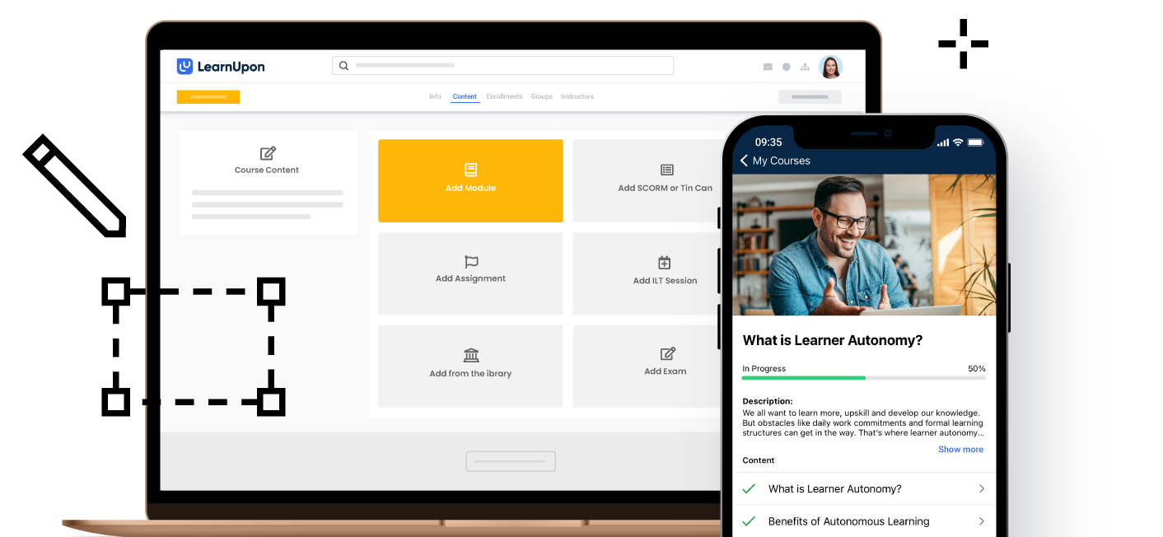

Figure 2: Automatically enroll learners in training using built-in functions and workflows.
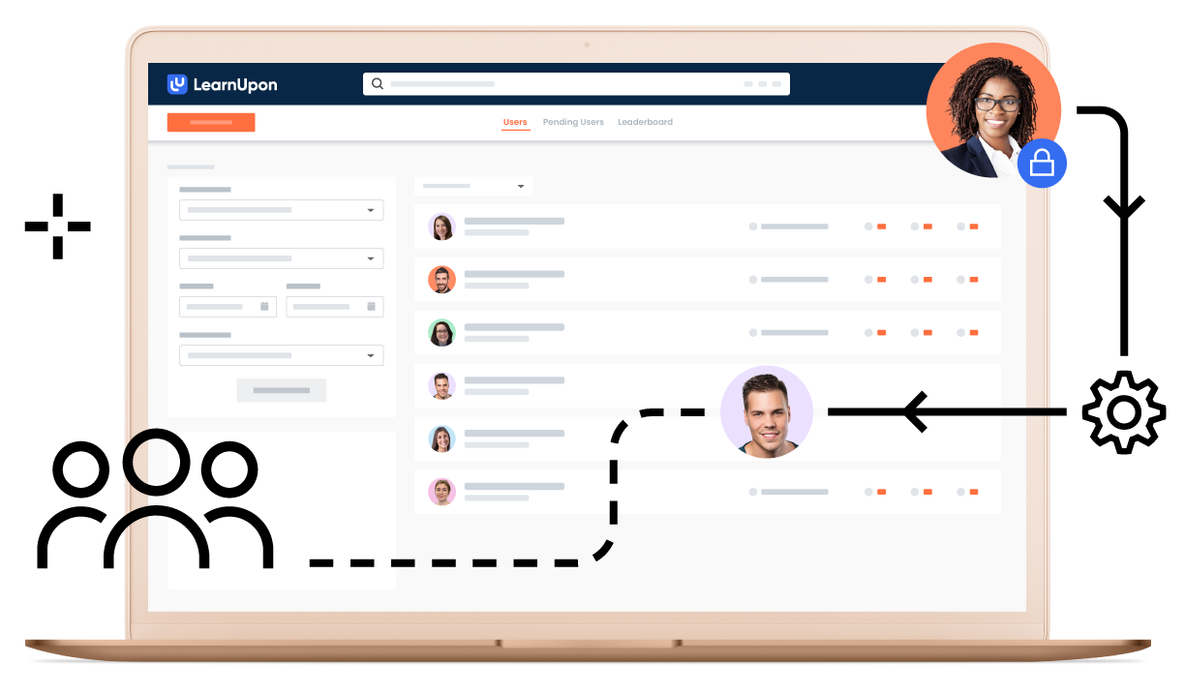

Figure 3: Measure impact with out-of-the-box and custom reports.

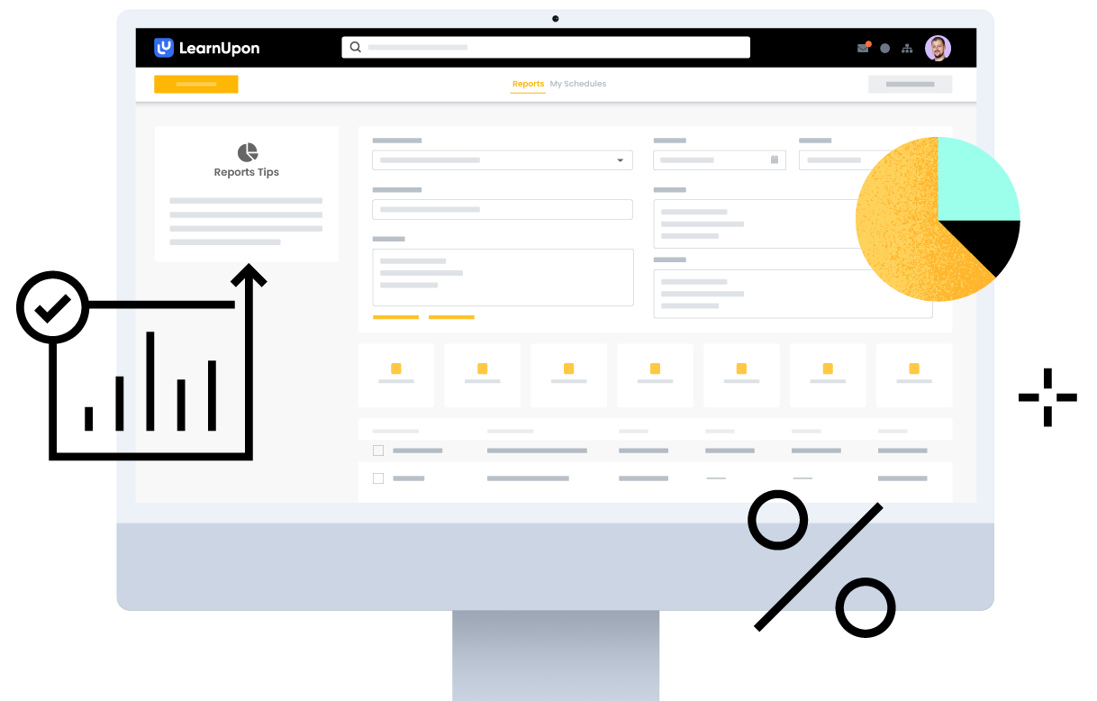

Figure 4: Deliver an intuitive, easy-to-use, and engaging experience across every device.

Figure 5: Encourage teams to hit their goals and place a spotlight on the best performing learners with Gamification and leaderboards.
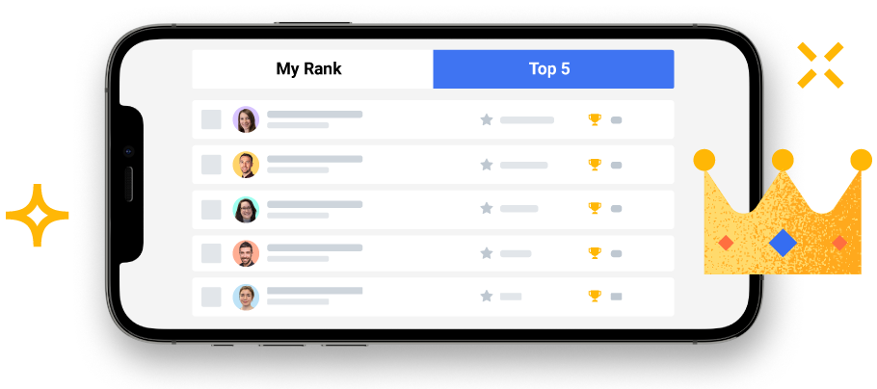

Figure 6: Configure training differently for each target audience or training type with LearnUpon’s Portals.
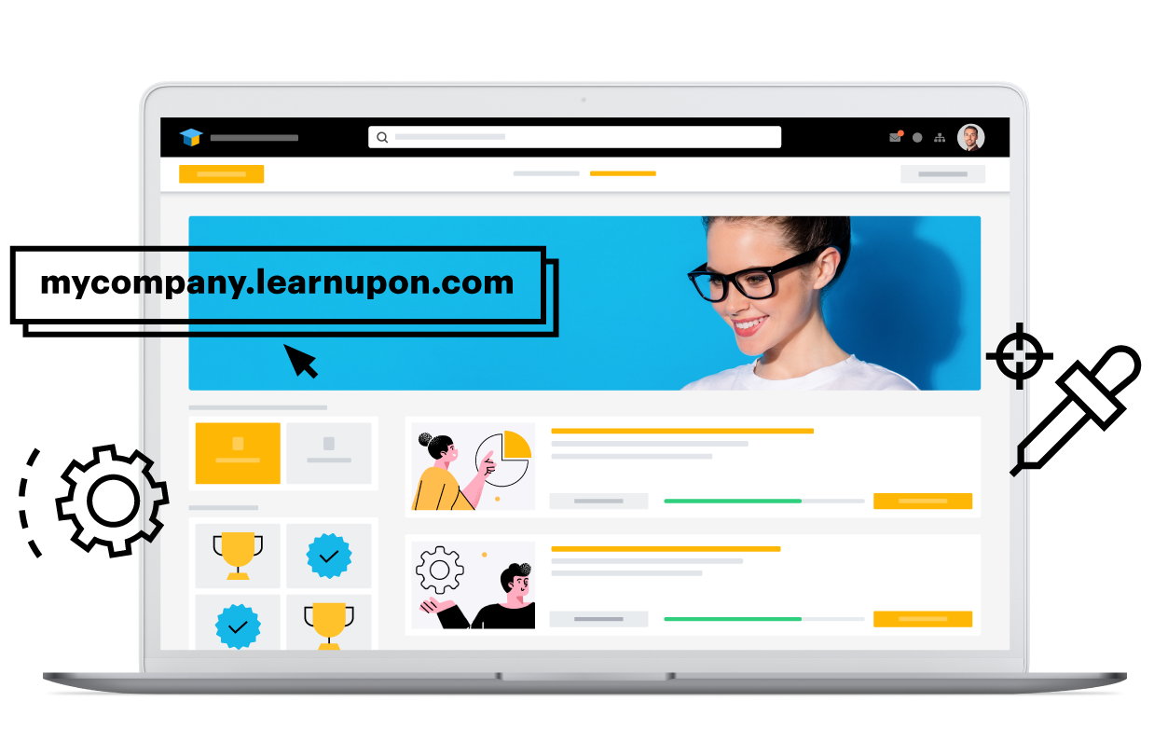

All images provided by LearnUpon.

Analysis by Brandon Hall Group
Situational Analysis
One of the biggest challenges around training for many organizations has been how to properly train people throughout the extended enterprise alongside employees, including partners, members, resellers, customers and more. The typical challenges presented by learning are exacerbated when the learning is being delivered to people who don’t necessarily work for the company. Several factors are driving corporations to improve both their internal and their extended enterprise training strategies:
- Improve Learner Engagement — Organizations struggle with developing and delivering learning content that captures the attention of the learner.
- Create a Stronger Link Between Learning and Performance — Learning in many organizations is developed without specific individual and organizational objectives in mind.
- Better Measurement — It can be difficult to measure the impact on performance among learners outside of the organization.
- Improve Accessibility to Content — Learners are highly mobile and have many situations where it is very complex to deliver an effective learning session.
Challenges to the Business
Organizations have had difficulty leveraging traditional LMS technologies to meet these new learner requirements. Learner requirements have evolved quickly and their need for content that is relevant, accessible and highly interactive is more important than ever. It can be particularly challenging to keep extended enterprise learners engaged and measure the effectiveness of their learning.
Implications for the Business
The implications are two-fold. For the learner, the learning experience is waning, and learner engagement continues to steadily decline. For the organization, a significant amount of financial and people resources is being consumed by learning organizations in leveraging their current LMS platforms — and still, the needs of the learner are not being met.
Questions to be Answered by the Business
Organizations need to rethink how they leverage technology to keep pace with the rapidly changing dynamics of their learners and business.
The key questions for the business are:
- Does the technology offer enough functionality to meet the requirements of learners?
- Can the technology support the extended enterprise ecosystem?
- Can the technology help track and measure the impact learning is having on external audiences?
LearnUpon as the Answer
LearnUpon’s platform features all the learning experience functionality an organization would need and expect for internal and external audiences. Its simple course creation tool allows admins to put together a wide array of courses or paths for different audiences, and the reporting feature is robust with sharp visualizations that put usable data at users’ fingertips. And as a next-gen learning technology should, LearnUpon offers social features and gamification on a fully mobile-ready platform. The platform is completely configurable to allow simplified branding and unique experiences for different audiences.
Beyond these features, however, is where LearnUpon begins to set itself apart. First, every element of the system is completely user-friendly, whether you are an internal learner (employee), an external learner, an admin or any other type of user. And the theme of ease of use carries over into implementation. LearnUpon prides itself on its quick, fully functional deployments. Clients can be up and running in weeks, whereas organizations deploying other systems are looking at months.
Another stand-out area for LearnUpon is their extended enterprise functionality. It is one of the few platforms that feels equally matched for internal and external learning audiences. The cloud-based, white-label nature of the solution means companies can deliver unique learning experiences to any external groups that need it — customers, members, resellers, franchisees and more alongside their regular workforce. Organizations with a large, complex extended enterprise environment can manage all their learning audiences through one master portal.
LearnUpon has long recognized that integrations are critical to successful learning technology implementations. LearnUpon has a variety of out-of-the-box integrations for the typical platform systems that organizations use, such as Salesforce, HubSpot and Teams, plus many other niche integrations via single sign-on that create almost instant synergy upon deployment. The data LearnUpon unlocks through its integrations with CRM partners makes measuring the impact of extended enterprise learning that much easier. Recent additions to their content partner network include Go1 and LinkedIn Learning. These content partnerships really round out the platform for companies looking to deliver learning to their employees.
LearnUpon has spent a lot of their time and energy on scaling their operations to reach even more customers with their best-in-class tools. In particular scaling R&D to continue improving their enterprise functionality and scaling their sales team to have a better global reach to all of their markets.
Perhaps their greatest innovation when it comes to partnering with customers in their success is their unique commitment to creating a strong results strategy for each customer. LearnUpon works with each of their customers in the learning function to craft, track, and celebrate the achievement of key business outcomes. Moving beyond traditional training outcomes, they help customers focus on results and by extension make those customers better internal partners.
As for functionality, LearnUpon is moving confidently into the age of AI by developing and integrating AI capabilities in the form of Content management, coaching, and learner insights – all of which are in various stages of development and testing. They have expanded their resources and reworked their content catalog functionality, improved the learner dashboard, and built a new UI for licensed content. LearnUpon continues to refine, improve, and expand it’s offering in keeping with the complex needs of today’s corporate learning environments.
LearnUpon has an industry-leading ROI that lowers the barrier to entry for any organization needing a world-class learning technology platform for internal and external learning audiences.

- Michael Rochelle, Chief Strategy Officer and Principal Analyst, Brandon Hall Group
-Matt Pittman, Principal Analyst, Brandon Hall Group

About Brandon Hall Group
With more than 10,000 clients globally and 28 years of delivering world-class research and advisory services, Brandon Hall Group is focused on developing research that drives performance in emerging and large organizations, and provides strategic insights for executives and practitioners responsible for growth and business results.
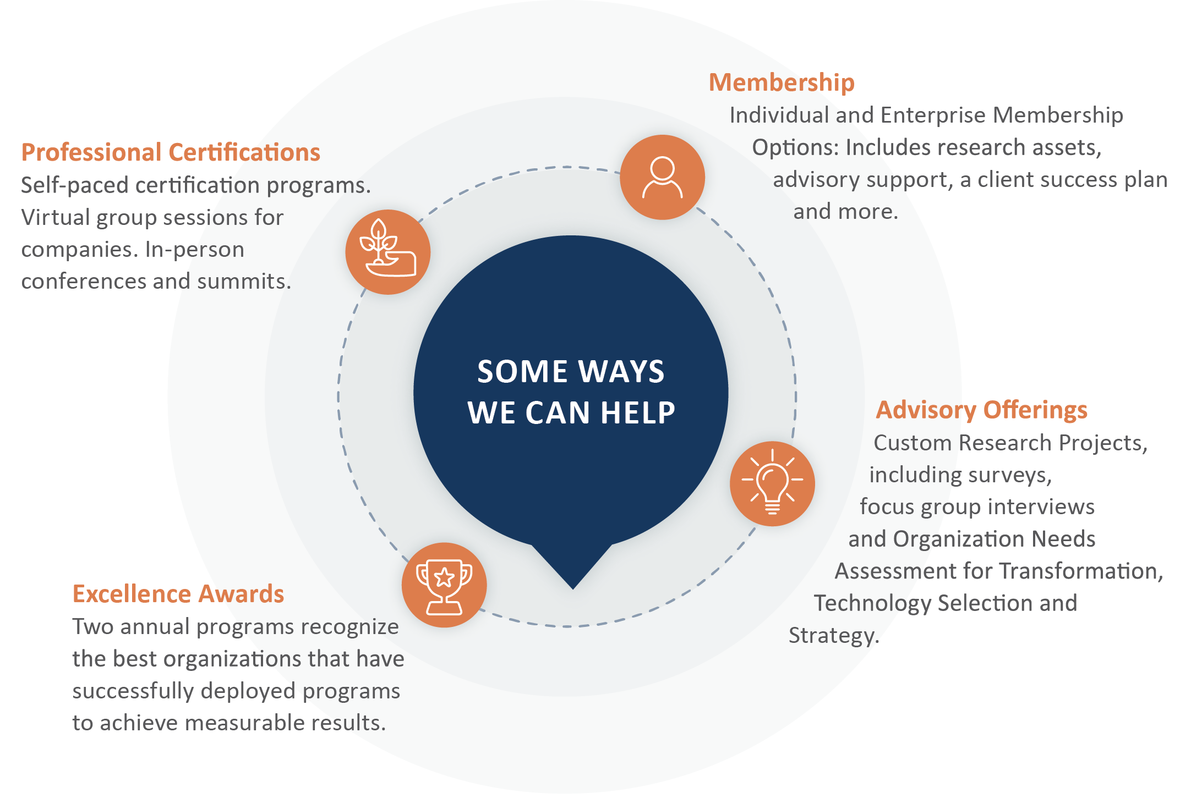


ORGANIZATIONAL EXCELLENCE CERTIFICATION PROGRAM
recognizes world-class HCM programs that transform their organization and achieve breakthrough results. This designation is the next step beyond the HCM Excellence Awards, which focus on a single program, and looks at the department as a whole.
SMARTCHOICE® PREFERRED
PROVIDER PROGRAM
uniquely places HCM service and technology companies at the top of organizations’ consideration list of vendors. It adds an unmatched level of credibility based on BHG’s twenty-eight-plus years’ experience in evaluating and selecting the best solution providers for leading organizations around the world.

